
The First Sunday
After Christmas
Christmas Lessons & Carols
December 28, 2025 • 11am

Welcome to St. Paul's! We are grateful you are joining us on this Sunday and look forward to welcoming you into this life we share through the love of Jesus Christ! Please don’t forget to silence your devices as our worship service begins.
Families are welcome to sit anywhere they would like, including our dedicated children's area in the Chapel, which features self-directed activities and books. Restrooms are located in the Parish Hall on the Occidental Avenue side of the church campus. Our worship service is live-streamed on St. Paul's YouTube Channel, where we welcome online friends to pray with us.
Thank you for sharing the light of your presence with our community this Christmastide! May God’s grace and peace be near to you in this holy season.

Prelude December & Nachspiel, Fanny Hensel (1805-1847)
December includes variations on the hymn “From heaven above to earth I come” (Vom Himmel hoch; Hymn 80).

All stand to sing
Processional Hymn 93 “Angels, from the realms of glory,” Regent Square

A Bidding Prayer

Officiant begins

Beloved in Christ, in this Christmastide, let it be our care and delight to hear again the message of the Angels, and in heart and mind to go even unto Bethlehem, and see this thing which is come to pass, and the Babe lying in a manger. Let us read and mark in Holy Scripture the tale of the loving purposes of God from the first days of our disobedience unto the glorious Redemption brought us by this holy Child; and let us make this place glad with our carols of praise.

But first, let us pray for the needs of his whole world; for peace and goodwill over all the earth; for the mission and unity of the Church for which Christ died, and especially for all whose kinship in God’s family waits for healing truth to be revealed in this country and within this city.

And because this, above all, would gladden God’s heart, let us at this time remember in Christ’s name the poor and the helpless, the hungry, the homeless, and the oppressed; the sick, the suffering, and all who mourn; the lonely and the unloved; the aged and the vulnerable; refugees and all young children, especially those who may find themselves in danger in this season; and, finally, all who do not yet know or love the Lord Jesus, or who by sin have grieved his heart of love.

Lastly, let us remember before God all those who rejoice with us, but upon another shore and in a greater light, that multitude which no man can number, whose hope was in the Word made flesh, and with whom, in this Lord Jesus, we for evermore are one.

These prayers and praises let us humbly offer up to the throne of heaven, in the words which Christ himself hath taught us:

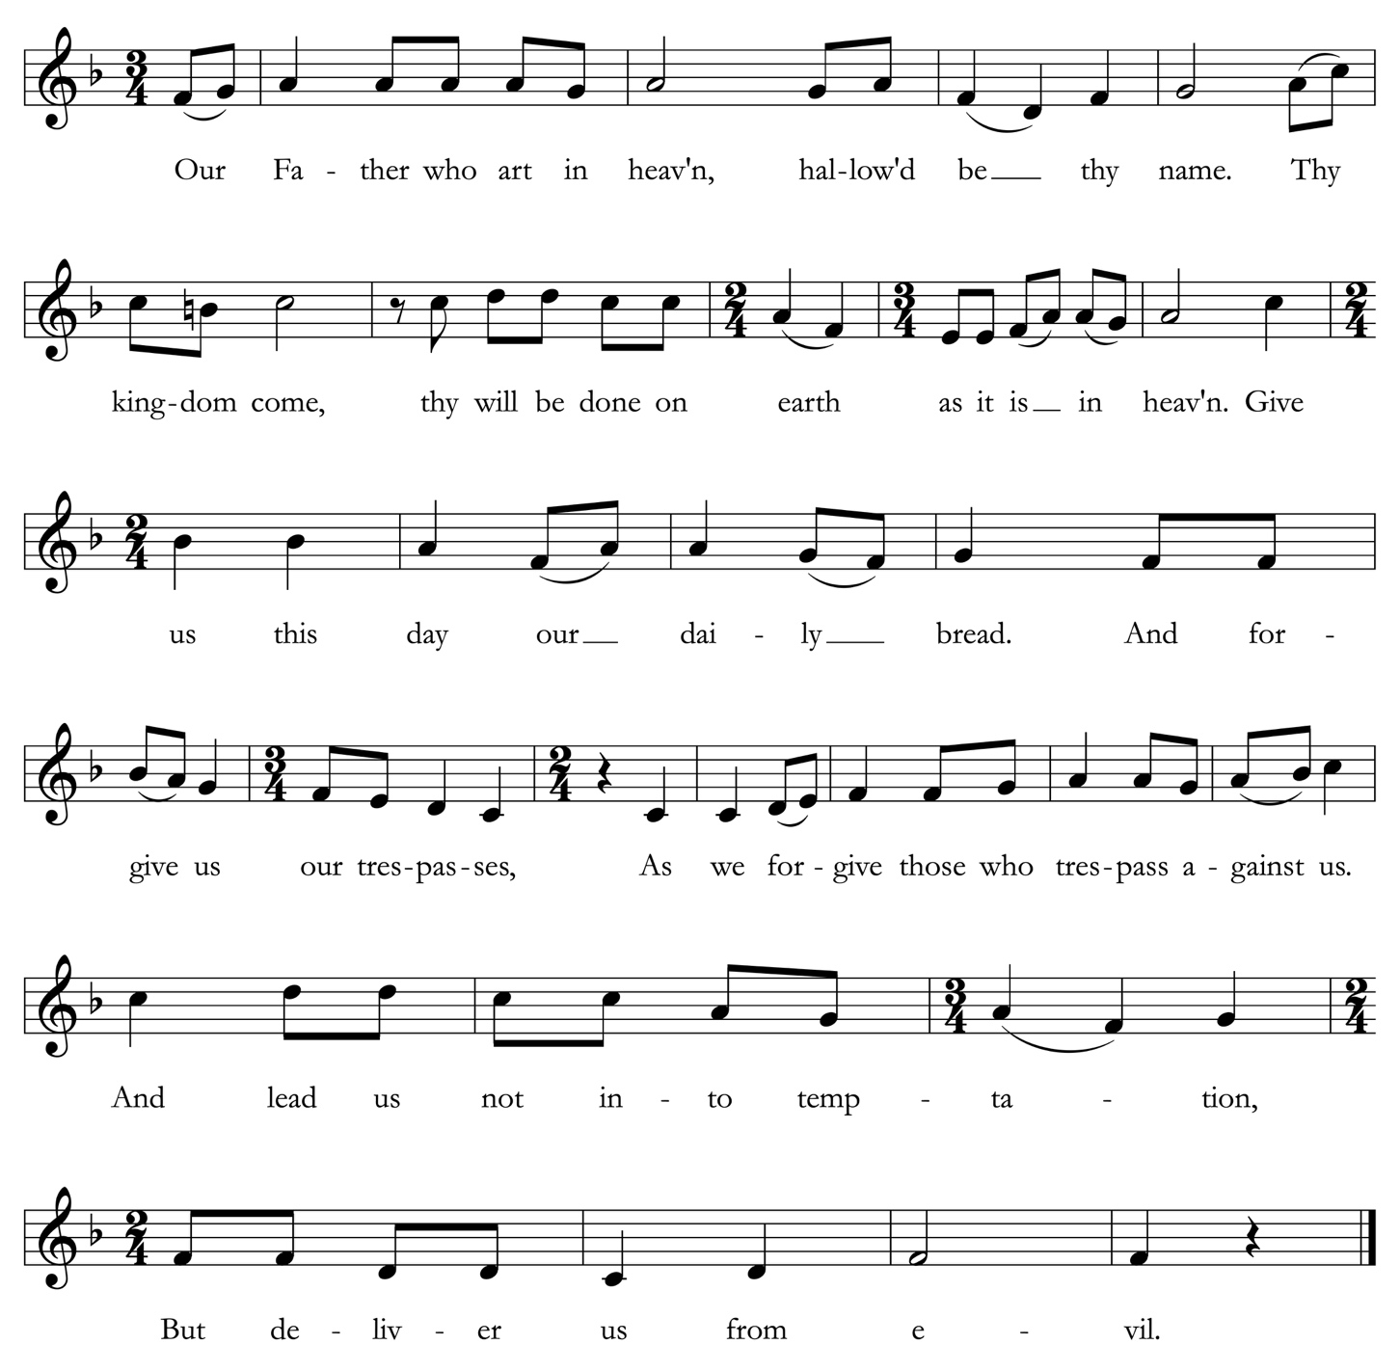
The Lord’s Prayer All are invited to sing Maurice Duruflé (1902-1986)

The people are seated.

First Lesson Isaiah 11: 1-3a; 4a; 6-9

A shoot shall come out from the stump of Jesse,
and a branch shall grow out of his roots.
The spirit of the Lord shall rest on him,
the spirit of wisdom and understanding,
the spirit of counsel and might,
the spirit of knowledge and the fear of the Lord.
His delight shall be in the fear of the Lord.
With righteousness he shall judge the poor,
and decide with equity for the meek of the earth;
The wolf shall live with the lamb,
the leopard shall lie down with the kid,
the calf and the lion and the fatling together,
and a little child shall lead them.
The cow and the bear shall graze,
their young shall lie down together;
and the lion shall eat straw like the ox.
The nursing child shall play over the hole of the asp,
and the weaned child shall put its hand on the adder's den.
They will not hurt or destroy on all my holy mountain;
for the earth will be full of the knowledge of the Lord
as the waters cover the sea.

All stand to sing stanzas 1 & 2
Hymn 81 “Lo, how a Rose,” Es ist ein Ros
The people are seated.

Second Lesson Luke 1: 26-35; 38

In the sixth month the angel Gabriel was sent by God to a town in Galilee called Nazareth, to a virgin engaged to a man whose name was Joseph, of the house of David. The virgin's name was Mary. And he came to her and said, “Greetings, favored one! The Lord is with you.” But she was much perplexed by his words and pondered what sort of greeting this might be.

The angel said to her, “Do not be afraid, Mary, for you have found favor with God. And now, you will conceive in your womb and bear a son, and you will name him Jesus. He will be great, and will be called the Son of the Most High, and the Lord God will give to him the throne of his ancestor David. He will reign over the house of Jacob forever, and of his kingdom there will be no end.”

Mary said to the angel, “How can this be, since I am a virgin?” The angel said to her, “The Holy Spirit will come upon you, and the power of the Most High will overshadow you; therefore the child to be born will be holy; he will be called Son of God.”

Then Mary said, “Here am I, the servant of the Lord; let it be with me according to your word.” Then the angel departed from her.

All stand to sing
Hymn 265 “The angel Gabriel from heaven came,” Gabriel’s Message
The people are seated.

Third Lesson Isaiah 61: 10-62:3

I will greatly rejoice in the Lord,
my whole being shall exult in my God;
for he has clothed me with the garments of salvation,
he has covered me with the robe of righteousness,
as a bridegroom decks himself with a garland,
and as a bride adorns herself with her jewels.
For as the earth brings forth its shoots,
and as a garden causes what is sown in it to spring up,
so the Lord God will cause righteousness and praise
to spring up before all the nations.
For Zion's sake I will not keep silent,
and for Jerusalem's sake I will not rest,
until her vindication shines out like the dawn,
and her salvation like a burning torch.
The nations shall see your vindication,
and all the kings your glory;
and you shall be called by a new name
that the mouth of the Lord will give.
You shall be a crown of beauty in the hand of the Lord,
and a royal diadem in the hand of your God.

All stand to sing
Hymn 100 “Joy to the world,” Antioch

The people are seated.

Fourth Lesson Luke 2: 1; 3-7

In those days a decree went out from Emperor Augustus that all the world should be registered. This was the first registration and was taken while Quirinius was governor of Syria. All went to their own towns to be registered.

Joseph also went from the town of Nazareth in Galilee to Judea, to the city of David called Bethlehem, because he was descended from the house and family of David. He went to be registered with Mary, to whom he was engaged and who was expecting a child.

While they were there, the time came for her to deliver her child. And she gave birth to her firstborn son and wrapped him in bands of cloth, and laid him in a manger, because there was no place for them in the inn.

All stand to sing
Hymn 101 “Away in a manger,” Cradle Song

The people are seated.

Fifth Lesson Luke 2: 8-16

In that region there were shepherds living in the fields, keeping watch over their flock by night. Then an angel of the Lord stood before them, and the glory of the Lord shone around them, and they were terrified.

But the angel said to them, “Do not be afraid; for see-- I am bringing you good news of great joy for all the people: to you is born this day in the city of David a Savior, who is the Messiah, the Lord. This will be a sign for you: you will find a child wrapped in bands of cloth and lying in a manger.” And suddenly there was with the angel a multitude of the heavenly host, praising God and saying,

“Glory to God in the highest heaven,
and on earth peace among those whom he favors!”

When the angels had left them and gone into heaven, the shepherds said to one another, “Let us go now to Bethlehem and see this thing that has taken place, which the Lord has made known to us.”

So they went with haste and found Mary and Joseph, and the child lying in the manger.

All stand to sing stanzas 1 & 3
Hymn 96 “Angels we have heard on high,” Gloria

Sixth Lesson Matthew 2: 1-12

In the time of King Herod, after Jesus was born in Bethlehem of Judea, wise men from the East came to Jerusalem, asking, “Where is the child who has been born king of the Jews? For we observed his star at its rising, and have come to pay him homage.”

When King Herod heard this, he was frightened, and all Jerusalem with him; and calling together all the chief priests and scribes of the people, he inquired of them where the Messiah was to be born.

They told him, “In Bethlehem of Judea; for so it has been written by the prophet:
‘And you, Bethlehem, in the land of Judah,
are by no means least among the rulers of Judah; for from you shall come a ruler
who is to shepherd my people Israel.’”

Then Herod secretly called for the wise men and learned from them the exact time when the star had appeared. Then he sent them to Bethlehem, saying, “Go and search diligently for the child; and when you have found him, bring me word so that I may also go and pay him homage.”

When they had heard the king, they set out; and there, ahead of them, went the star that they had seen at its rising, until it stopped over the place where the child was. When they saw that the star had stopped, they were overwhelmed with joy. On entering the house, they saw the child with Mary his mother; and they knelt down and paid him homage. Then, opening their treasure chests, they offered him gifts of gold, frankincense, and myrrh. And having been warned in a dream not to return to Herod, they left for their own country by another road.

All stand to sing stanzas 1-5
Hymn 109 “The first Nowell,” English carol

The people are seated.

Seventh Lesson John 1: 1-18

In the beginning was the Word, and the Word was with God, and the Word was God. He was in the beginning with God. All things came into being through him, and without him not one thing came into being. What has come into being in him was life, and the life was the light of all people. The light shines in the darkness, and the darkness did not overcome it.

There was a man sent from God, whose name was John. He came as a witness to testify to the light, so that all might believe through him. He himself was not the light, but he came to testify to the light. The true light, which enlightens everyone, was coming into the world.

He was in the world, and the world came into being through him; yet the world did not know him. He came to what was his own, and his own people did not accept him. But to all who received him, who believed in his name, he gave power to become children of God, who were born, not of blood or of the will of the flesh or of the will of man, but of God.

And the Word became flesh and lived among us, and we have seen his glory, the glory as of a father's only son, full of grace and truth. (John testified to him and cried out, “This was he of whom I said, ‘He who comes after me ranks ahead of me because he was before me.’”) From his fullness we have all received, grace upon grace. The law indeed was given through Moses; grace and truth came through Jesus Christ. No one has ever seen God. It is God the only Son, who is close to the Father’s heart, who has made him known.

All stand to sing
Hymn 99 “Go tell it on the mountain,” Spiritual

Offertory Sentence

Officiant invites
In this sacred season, we give thanks for God’s generous grace, sending his only son to live among us in great humility. And we celebrate your daring to brighten the world by sharing the goodness we have known in Christ’s ultimate gift. Such sacrifices of love indeed are pleasing to God, who desires that all might know love’s redeeming embrace, now and throughout the coming year.

The people are seated.

Ushers pass collection plates to receive communal Christmas gifts and offerings. Thank you for your generous support of the mission and ministries of St. Paul’s, in this holy season and throughout the year ahead!

Offertory Anthem “To God be the glory,” ‘Ā Hake Kai Nga
sung by the Choir of Sa Paula Tonga

All stand to sing
Presentation Hymn 115 “What child is this,” Greensleeves

Concluding Collect and Blessing

Officiant The Lord be with you.
People And also with you.
Officiant Let us pray.

O God, you make us glad with the yearly remembrance of the birth of your only Son, Jesus Christ. Grant that as we joyfully receive him as our redeemer, that we also with sure confidence may behold him when he shall come again to be our judge, who lives and reigns with you and the Holy Spirit, one God, now and forever. Amen.

Now may Almighty God bless us with his grace; Christ give us the joys of everlasting life; and the King of Angels bring us all into the blessed fellowship of the saints in heaven and earth. Amen.

All sing
Hymn 87 “Hark! the herald angels sing,” Mendelssohn

The Dismissal

Officiant Let us go in the peace of Christ. Alleluia, alleluia.
People Thanks be to God. Alleluia, alleluia.

Postlude In dir ist Freude, Johann Sebastian Bach (1685-1750)
Ministers of worship

Altar Guild: Denora Smith, Edith Foothorap
Greeters & Ushers: Ron Goerss, Vic Carboni, Jack Marsal
Acolyte: Vilson Marangco, Will Vander Lugt
Lectors: Alex Fa’avae, Sa’ane Mila, Nathan Fa’avae, Robin Raborn,
Jack Marsal, Joan Cleary, Taiana Fa’avae
A/V: John Kendall
Assistant: Jocelyn A. Sideco, MTS
Organist and Accompanist: Dr. Susan Jane Matthews
Officiant: Bill Phillips

End of the Year Reminder
Wednesday, January 7, 2026, is the last day to submit any pledge payments or gifts to St. Paul's to be credited on 2025 tax statements that will be sent out at the end of January. They can be made by bank transfer or check dated on or before December 31, 2025. Online payments and stock transfers need to be completed by midnight on December 31, 2025 to be shown on 2025 statements for tax purposes. To give online, go to stpaulsburlingame.org/support and scroll down to "Give to St. Paul's." Haven't pledged yet for 2026? You can also make your confidential pledge (no payment needed) online at the same link or emailing tnbusselle@gmail.com.


Copyright Acknowledgments. Reprinted under OneLicense.net #A-706347 and a Rite Song reprint license for congregational use.

St. Paul’s Episcopal Church, Burlingame, CA 94010 • 650.348.4811 • www.stpaulsburlingame.org
CHRISTMAS FLOWER & MUSIC DEDICATIONS
With gratitude and appreciation, St. Paul’s thanks all who contributed
to the special music and flowers for this year’s commemoration of the Feast of the Incarnation.

Leslie Smith
With love and gratitude
for the blessings of my children and grandchildren;
Trevor Lewellen; Victor, Addison, Diego
and Elena Gaitan

✠

Tish and Jim Busselle
In gratitude for St. Paul’s community

✠

Anne Casscells & Susan Ketcham
In honor of Susan’s mom, Bunty Ketcham

✠

Tom and Cyndy Bodenlos
Merry Christmas to the St. Paul’s community

✠

The Rev. Sarah C. Stewart
With gratitude for the dedication and care
of St. Paul's Vestry, Ministry Leaders,
and Staff & prayers for God’s peace and joy
to bless our whole community this Christmas!

✠

The Culatana / Ding Family
In memory of Felix Y. Feng

Cisca Hansen
To the Glory of God and in thanksgiving

✠

Jenny Lau
For the loving memory of Andrew

✠

Ann Lowry and John A. Perez
In memory of Mary and Robert N. Lowry

✠

Sandy Galindo & Family
In memory of Raul Galindo & June Castelli – always in our hearts

✠

Sandy Galindo
To Rev. Sarah+ & my church family for all your love and support in this trying year

✠

Susan Jane Matthews
Merry Christmas to the Choir of St. Paul’s!

✠

Candace and James Martin
Remembering loved ones past and present

✠
Pat Ko

