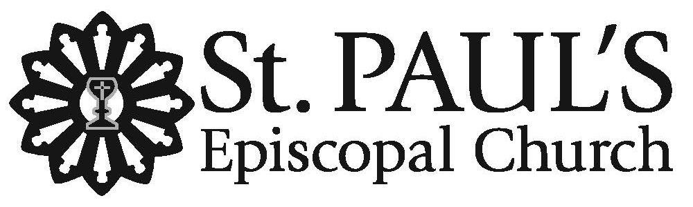

The Feast of the Incarnation
Christmas Day
December 25, 2025 • 11am

Welcome to St. Paul's! We are glad you are worshiping with us on this Christmas Day. Children indeed are most welcome here. The order for service is found in this leaflet. The people’s responses are indicated by bold type. Hymns may be found in the blue Hymnal 1982 in the pew rack. Restrooms are located in Foote Hall on the Occidental Street side of the church campus. This worship service may be live-streamed on St. Paul's YouTube Channel, where we welcome online friends to pray with us.
All are warmly invited to participate in Holy Communion at St. Paul’s. If you prefer not to receive the wine, simply cross your arms over your chest as the Eucharistic Minister greets you saying, “the Blood of Christ, the Cup of Salvation.” We wish you God’s comfort, peace, and joy this Christmas!

Prelude Noël Grand Jeu et Duo, Louis-Claude d’Aquin (1694-1772)

All stand to sing
Processional Hymn 107 “Good Christian friends, rejoice,” In dulci jubilo

Opening Acclamation

Celebrant The Word became flesh and dwelt among us,
People full of wisdom, grace, and truth.

Celebrant And we have seen that glory, the glory of God's only begotten son.
People The Word became flesh and dwelt among us,
full of wisdom, grace, and truth.

All sing stanzas 1 & 3

Song of Praise: Hymn 96 “Angels we have heard on high,” Gloria

The Collect of the Day

Celebrant The Lord be with you.
People And also with you.
Celebrant Let us pray.

A moment of silence is observed as we prepare our hearts for prayer.

O God, you make us glad by the yearly festival of the birth of your only Son Jesus Christ: Grant that we, who joyfully receive him as our Redeemer, may with sure confidence behold him when he comes to be our Judge; who lives and reigns with you and the Holy Spirit, one God, now and for ever. Amen.

The people are seated.

The First Lesson Isaiah 52: 7-10

How beautiful upon the mountains
are the feet of the messenger who announces peace,
who brings good news,
who announces salvation,
who says to Zion, “Your God reigns.”
Listen! Your sentinels lift up their voices,
together they sing for joy;
for in plain sight they see
the return of the Lord to Zion.
Break forth together into singing,
you ruins of Jerusalem;
for the Lord has comforted his people,
he has redeemed Jerusalem.
The Lord has bared his holy arm
before the eyes of all the nations;
and all the ends of the earth shall see
the salvation of our God.

After the reading, the reader says

Reader Hear what the Spirit is saying to God’s people.
People Thanks be to God.

All stand to sing.

Gradual Hymn 89 “It came upon the midnight clear,” Carol

The Second Lesson Hebrews 1: 1-4

Long ago God spoke to our ancestors in many and various ways by the prophets, but in these last days he has spoken to us by a Son, whom he appointed heir of all things, through whom he also created the worlds. He is the reflection of God's glory and the exact imprint of God's very being, and he sustains all things by his powerful word. When he had made purification for sins, he sat down at the right hand of the Majesty on high, having become as much superior to angels as the name he has inherited is more excellent than theirs.

After the reading, the reader says

Reader Hear what the Spirit is saying to God’s people.
People Thanks be to God.

All stand to sing.

Alleluia Verse Chant, based on the O Antiphons
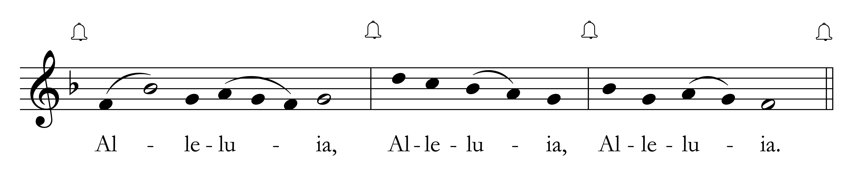
Cantor sings Alleluia. All sing Alleluia.

Cantor: For a child has been born for us, a son given to us;
and he is named Wonderful Counselor, Mighty God, Everlasting Father, Prince of Peace.

All sing Alleluia.

The Holy Gospel John 1: 1-14

Reader The Holy Gospel of our Lord Jesus Christ according to John.
People Glory to you, Lord Christ.

In the beginning was the Word, and the Word was with God, and the Word was God. He was in the beginning with God. All things came into being through him, and without him not one thing came into being. What has come into being in him was life, and the life was the light of all people. The light shines in the darkness, and the darkness did not overcome it.
There was a man sent from God, whose name was John. He came as a witness to testify to the light, so that all might believe through him. He himself was not the light, but he came to testify to the light. The true light, which enlightens everyone, was coming into the world.
He was in the world, and the world came into being through him; yet the world did not know him. He came to what was his own, and his own people did not accept him. But to all who received him, who believed in his name, he gave power to become children of God, who were born, not of blood or of the will of the flesh or of the will of man, but of God.
And the Word became flesh and lived among us, and we have seen his glory, the glory as of a father's only son, full of grace and truth.

Reader The Gospel of the Lord.
People Praise to you, Lord Christ.

The people are seated.

The Sermon The Rev. Nick W. Roosevelt

The Nicene Creed

Said by all, standing.

We believe in one God, the Father, the Almighty,
maker of heaven and earth, of all that is, seen and unseen.

We believe in one Lord, Jesus Christ, the only Son of God,
eternally begotten of the Father, God from God, Light from Light,
true God from true God, begotten, not made, of one Being with the Father.
Through him all things were made.
For us and for our salvation he came down from heaven;
by the power of the Holy Spirit
he became incarnate from the Virgin Mary, and was made man.
For our sake he was crucified under Pontius Pilate;
he suffered death and was buried.
On the third day he rose again in accordance with the Scriptures;
he ascended into heaven and is seated at the right hand of the Father.
He will come again in glory to judge the living and the dead,
and his kingdom will have no end.

We believe in the Holy Spirit, the Lord, the giver of life,
who proceeds from the Father and the Son.
Who with the Father and the Son is worshipped and glorified.
Who has spoken through the Prophets.
We believe in one holy catholic and apostolic Church.
We acknowledge one baptism for the forgiveness of sins.
We look for the resurrection of the dead, and the life of the world to come. Amen.

The Prayers of the People The Book of Common Prayer, p. 385

I ask your prayers for God’s people throughout the world; for Sean, our Presiding Bishop; and Austin, our Bishop in the Diocese of California; for this gathering; and for all ministers and people. Pray for the Church.
The people offer their own prayers.

I ask your prayers for peace; for goodwill among nations;
and for the well-being of all people. Pray for justice and peace.
The people offer their own prayers.

I ask your prayers for the poor, the sick, the hungry, the oppressed, and those in prison.
Pray for those in any need or trouble.
The people offer their own prayers.

I ask your prayers for all who seek God, or a deeper knowledge of him.
Pray that they may find and be found by him.
The people offer their own prayers.

I ask your prayers for the departed. Pray for those who have died.
The people offer their own prayers.

Praise God for those in every generation in whom Christ has been honored.
Pray that we may have grace to glorify Christ in our own day.
The people offer their own prayers.

The Celebrant concludes the prayers with

Holy One, hear these prayers we bring to you and fulfill your purposes in us through the love of Jesus, your Incarnate Word. Amen.

The Peace

Celebrant The peace of Christ be with you always.
People And also with you.

The people greet each other with the sign of God’s peace. All are then seated.

Announcements

Offertory Sentence

Offertory Anthem 16th-century French carol, arr. Charles Wood

Ding dong! merrily on high in heav’n the bells are ringing!
Ding dong! verily the sky is riv’n with angels singing!
Gloria! Hosanna in excelsis!

E’en so here below, below, let steeple bells be swungen,
And “I-o, i-o, i-o!” by priest and people sungen!
Gloria! Hosanna in excelsis!

Pray you, dutifully prime your matin chime, ye ringers!
May you beautifully rime your evetime song, ye singers!
Gloria! Hosanna in excelsis!

All stand to sing.

Presentation Hymn 112 “In the bleak midwinter,” Cranham

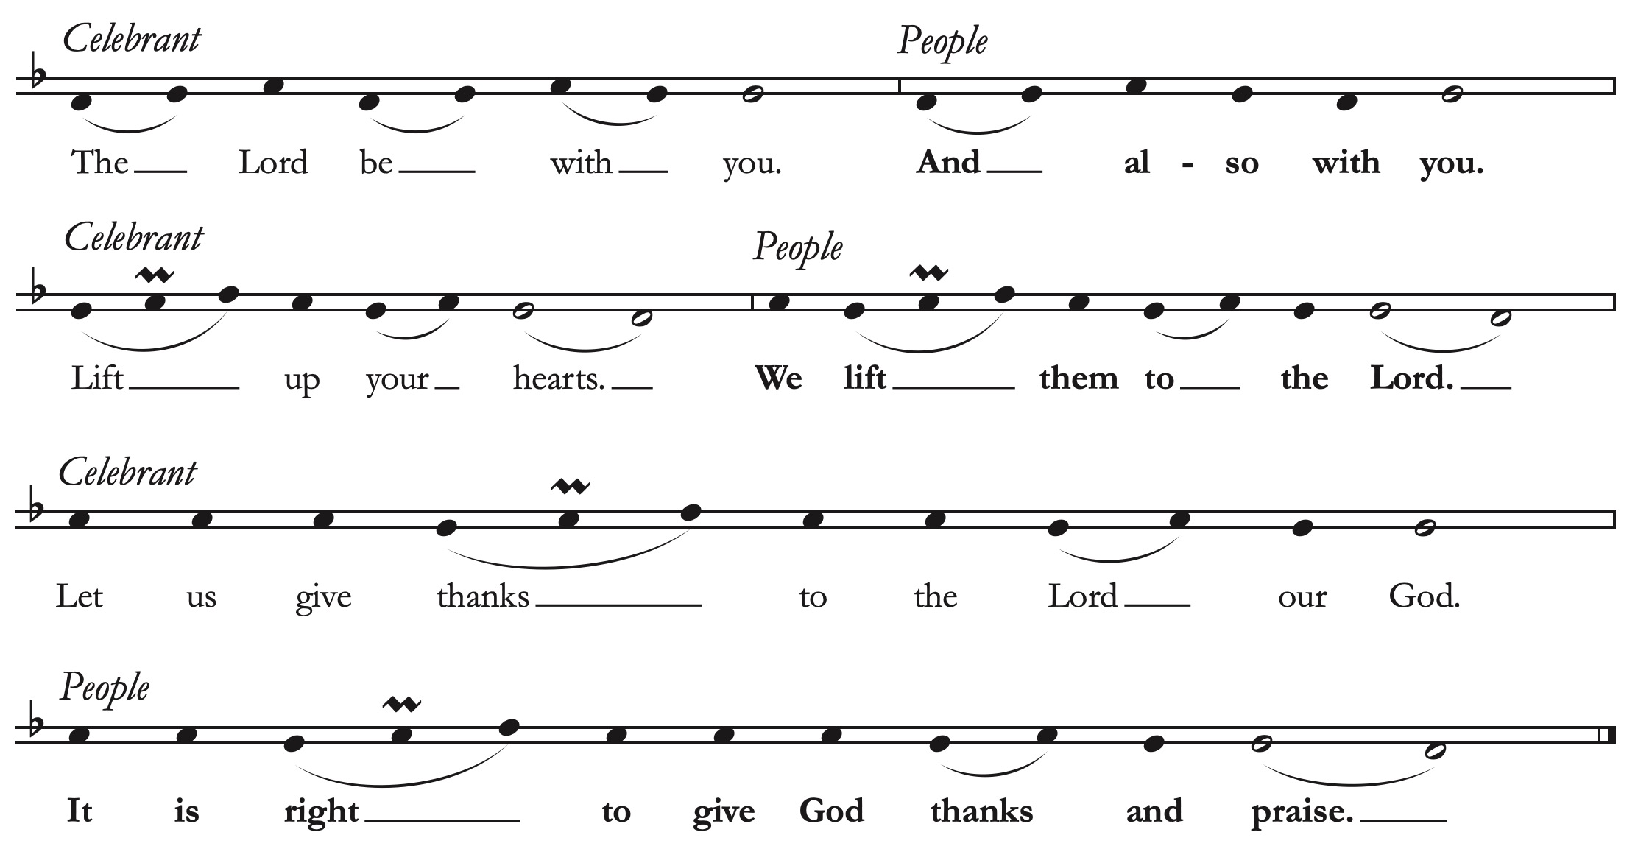
The Great Thanksgiving Eucharistic Prayer B, The Book of Common Prayer, p. 367

The Celebrant continues with the Eucharistic Prayer,

It is right, and a good and joyful thing, always and everywhere to give thanks to you, Father Almighty, Creator of heaven and earth.

Because you gave Jesus Christ, your only Son, to be born for us; who, by the mighty power of the Holy Spirit, was made perfect Man of the flesh of the Virgin Mary his mother; so that we might be delivered from the bondage of sin, and receive power to become your children.

Therefore we praise you, joining our voices with Angels and Archangels and with all the company of heaven, who for ever sing this hymn to proclaim the glory of your Name:

All sing
Sanctus harmony at S 130 Franz Schubert (1797-1828)
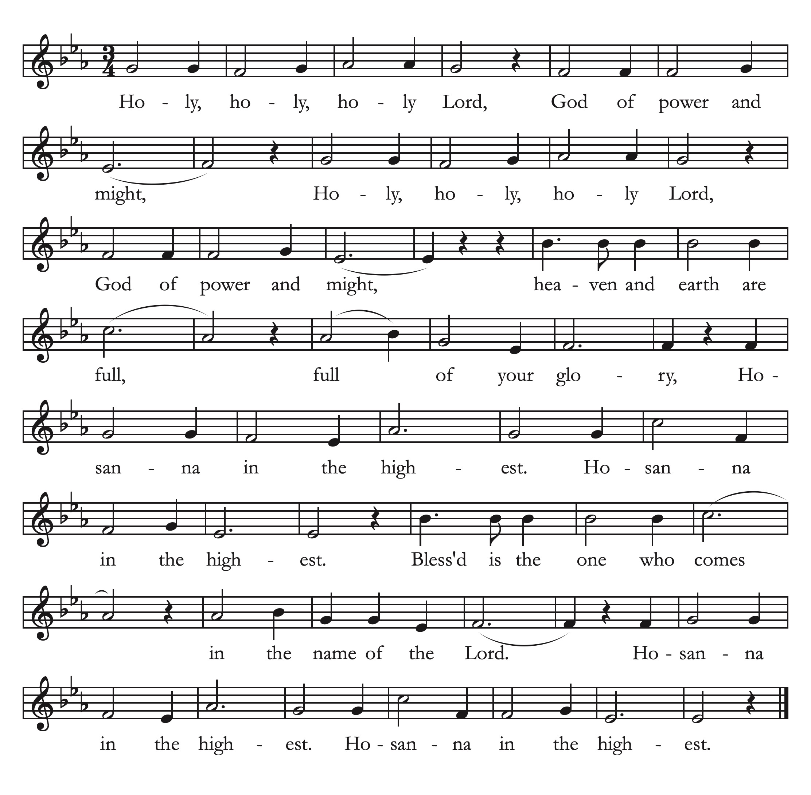

The people stand or kneel, as the Celebrant continues the Eucharistic Prayer,

We give thanks to you, O God, for the goodness and love which you have made known to us in creation; in the calling of Israel to be your people; in your Word spoken through the prophets; and above all in the Word made flesh, Jesus, your Son. For in these last days you sent him to be incarnate from the Virgin Mary, to be the Savior and Redeemer of the world. In him, you have delivered us from evil, and made us worthy to stand before you. In him, you have brought us out of error into truth, out of sin into righteousness, out of death into life.

On the night before he died for us, our Savior Jesus Christ took bread; and when he had given thanks to you, he broke it, and gave it to his disciples, and said, “Take, eat: This is my Body,
which is given for you. Do this for the remembrance of me.” After supper he took the cup of wine; and when he had given thanks, he gave it to them, and said, “Drink this, all of you: This is my Blood of the new Covenant, which is poured out for you and for all for the forgiveness of sins. Whenever you drink it, do this for the remembrance of me.”
Therefore, according to his command, Almighty God,

Celebrant and People
We remember his death,
We proclaim his resurrection,
We await his coming in glory;

The Celebrant continues,
And we offer our sacrifice of praise and thanksgiving to you, O Savior of all; presenting to you, from your creation, this bread and this wine.

We pray you, gracious God, to send your Holy Spirit upon these gifts that they may be the Sacrament of the Body of Christ and his Blood of the new Covenant. Unite us to your Son in his sacrifice, that we may be acceptable through him, being sanctified by the Holy Spirit. In the fullness of time, put all things in subjection under your Christ, and bring us to that heavenly country where, with all your saints, we may enter the everlasting heritage of your children; through Jesus Christ our Savior, the firstborn of all creation, the head of the Church, and the author of our salvation.

By whom, and with whom, and in whom, in the unity of the Holy Spirit all honor and glory is yours, Most Blessed One, now and for ever. AMEN.

And now, as our Savior Christ has taught us, we are bold to pray:

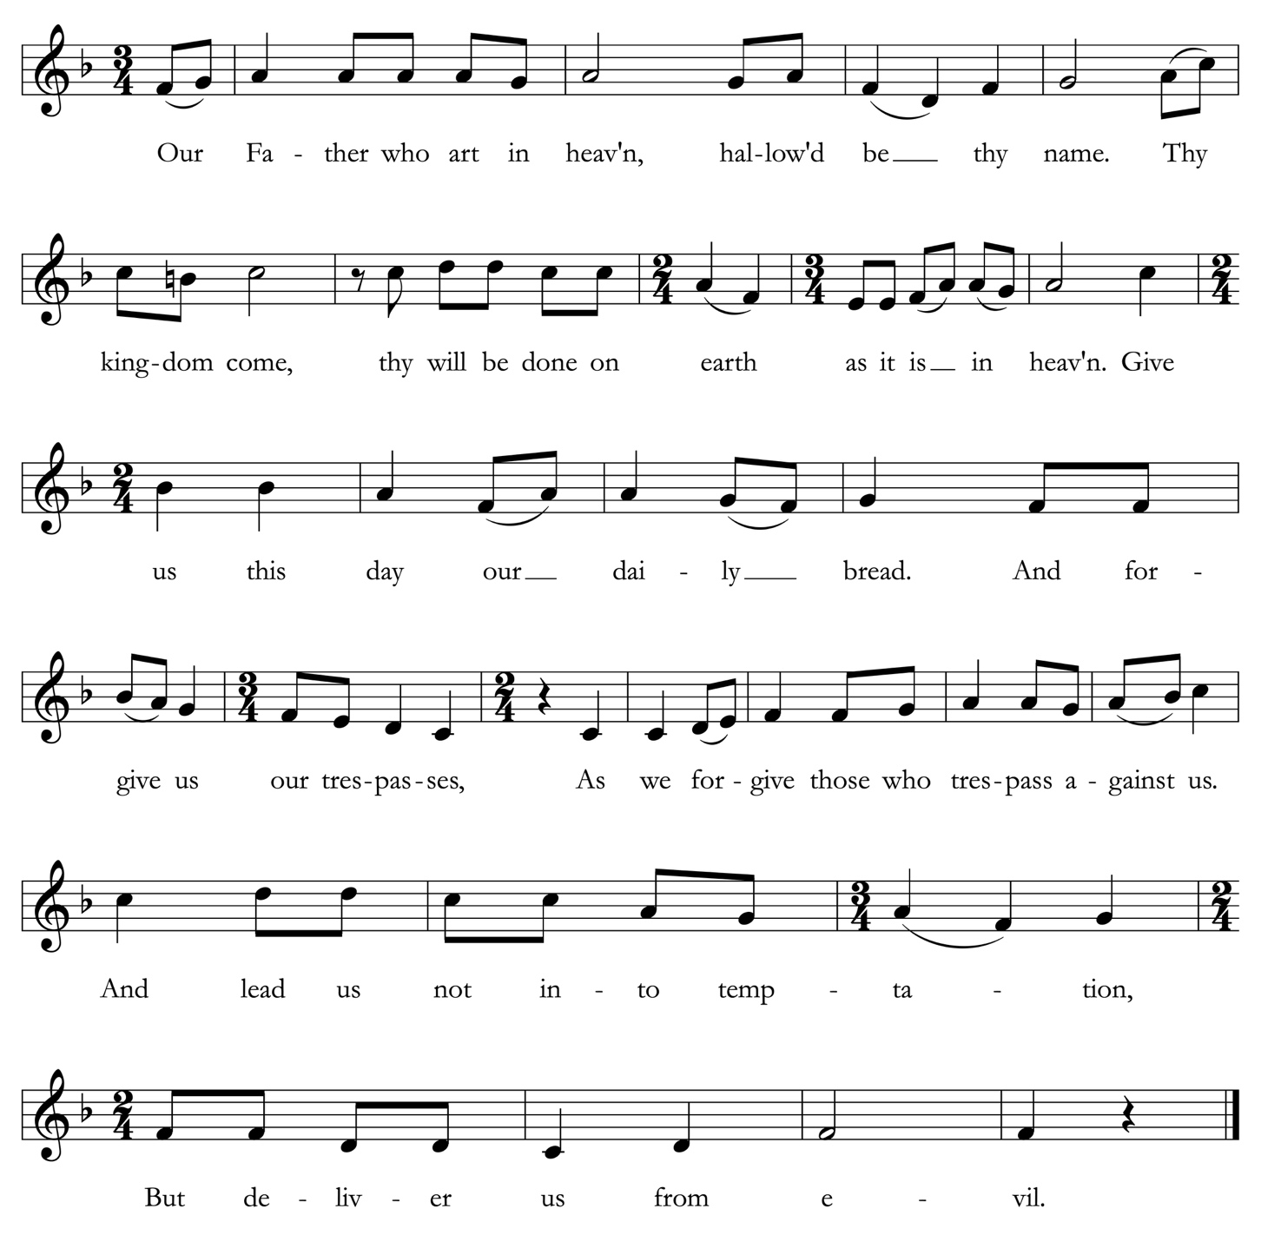
The Lord’s Prayer All are invited to sing. Maurice Duruflé (1902-1986)

The Breaking of the Bread
The Celebrant breaks the bread. A period of silence is kept.

Agnus Dei Deutsche Messe, Franz Schubert

Invitation to Communion

The Table is ready. So come, you who have much faith and you who would like to have more; you who have been here often and you who have not been for a long time; you who have tried to follow Jesus, and you who have failed. Come, because it is Christ who invites us to meet God here.

All are welcome to receive Communion. Gluten-free wafers are available upon request. Please participate as you feel most comfortable, by receiving 1) a prayer of blessing; 2) consecrated bread or wine; 3) the bread and a blessing; 4) the bread and a sip from the chalice. Please only sip, do not dip. Ushers will see that Communion is brought to you, should you request it.
Communion Anthem The holly and the ivy, English carol; arr. H. Walford Davies

The holly and the ivy when they are both full grown;
Of all the trees that are in the wood the holly bears the crown.
O the rising of the sun and the running of the deer, The playing of the merry organ, sweet singing in the choir.

The holly bears a blossom as white as any flower;
And Mary bore sweet Jesus Christ to be our sweet Savior. O the rising . . .

The holly bears a berry as red as any blood;
And Mary bore sweet Jesus Christ to do poor sinners good. O the rising . . .

The holly bears a prickle as sharp as any thorn;
And Mary bore sweet Jesus Christ on Christmas Day in the morn. O the rising . . .

The holly bears a bark as bitter as any gall;
And Mary bore sweet Jesus Christ for to redeem us all. O the rising . . .

All stand to say.

The Postcommunion Prayer

Eternal God, heavenly Father, you have graciously accepted us as living members of your Son our Savior Jesus Christ, and you have fed us with spiritual food in the Sacrament of his Body and Blood. As you have poured upon us the new light of your Incarnate Word,
grant us comfort, strength, and courage, that this same light enkindled in our hearts may shine forth in our lives, through Christ our Lord. Amen.

The Blessing

May Almighty God, who sent his Son to take our nature upon him, bless you in this holy season, scatter the darkness of sin, and brighten your heart with the light of his holiness.

May God, who sent his angels to proclaim the glad news of the Savior’s birth,
fill you with joy, and make you heralds of the Gospel.

May God, who in the Word made flesh joined heaven to earth and earth to heaven,
give you his peace and favor.

And the blessing of God Almighty, the Father, the Son, and the Holy Spirit, be upon you and remain with you for ever. Amen.

All stand to sing.

Hymn 105 “God rest you merry, gentlemen,” 18th-century London carol

The Dismissal

Preacher Go forth in the name of Christ. Alleluia, alleluia!
People Thanks be to God. Alleluia, alleluia!

Postlude Fantasia on “In dulci jubilo,” BWV 729, Johann Sebastian Bach (1685-1750)

Copyright Acknowledgments. Reprinted under OneLicense.net #A-706347 and a Rite Song reprint license for congregational use.
CHRISTMAS FLOWER & MUSIC DEDICATIONS
With gratitude and appreciation, St. Paul’s thanks all who contributed
to the special music and flowers for this year’s commemoration of the Feast of the Incarnation.

Leslie Smith
With love and gratitude
for the blessings of my children and grandchildren;
Trevor Lewellen; Victor, Addison, Diego
and Elena Gaitan

✠

Tish and Jim Busselle
In gratitude for St. Paul’s community

✠

Anne Casscells & Susan Ketcham
In honor of Susan’s mom, Bunty Ketcham

✠

Tom and Cyndy Bodenlos
Merry Christmas to the St. Paul’s community

✠

The Rev. Sarah C. Stewart
With gratitude for the dedication and care
of St. Paul's Vestry, Ministry Leaders,
and Staff & prayers for God’s peace and joy
to bless our whole community this Christmas!

✠

The Culatana / Ding Family
In memory of Felix Y. Feng

Cisca Hansen
To the Glory of God and in thanksgiving

✠

Jenny Lau
For the loving memory of Andrew

✠

Ann Lowry and John A. Perez
In memory of Mary and Robert N. Lowry

✠

Sandy Galindo & Family
In memory of Raul Galindo & June Castelli – always in our hearts

✠

Sandy Galindo
To Rev. Sarah+ & my church family for all your love and support in this trying year

✠

Susan Jane Matthews
Merry Christmas to the Choir of St. Paul’s!

✠

Candace and James Martin
Remembering loved ones past and present

✠
Pat Ko

Ministers of worship

Altar Guild: Michelle Bosschart, Edith Foothorap
Communion Bread: Kathy Martin
Greeters & Ushers: Rob Adams, Cisca Hansen
Acolyte: Vilson Marangco
Lectors: Beth Beisecker, Anne Morse, Kathy Martin
A/V: James Martin
Celebrant: The Rev. Sarah C. Stewart
Preacher: The Rev. Nick W. Roosevelt
Assistant: Ms. Jocelyn A. Sideco, MTS
Musicians: The Choir of St. Paul’s; Susan Jane Matthews, Director of Music



St. Paul’s Episcopal Church • 415 El Camino Real Burlingame, CA 94010 • 650.348.4811 www.stpaulsburlingame.org

