

Holy Eucharist
The 23rd Sunday after Pentecost
November 16, 2025 • 10:00am

Welcome to St. Paul's! We are grateful for your presence in worship and look forward to welcoming you into this life we share through the love of Jesus Christ! Please don’t forget to silence your devices as our worship service begins.

Families are welcome to sit anywhere they would like, including in our dedicated children's area in the Chapel, which features self-directed activities and books. An all-gender restroom and a ladies’ room are located in the Parish Hall on the Occidental Avenue side of the church campus. Children’s Chapel activities also take place in that building on Sundays featuring those group offerings. Our worship service is live-streamed on St. Paul's YouTube Channel, where we welcome online friends to pray with us.

All are warmly invited to participate in Holy Communion at St. Paul’s. If you prefer not to receive the wine, simply cross your arms over your chest as the Eucharistic Minister greets you saying, “the Blood of Christ, the Cup of Salvation.” Thank you for sharing the light of your presence with our community! May God’s presence be very near to you in this holy season!

Prelude November (Das Jahr), Fanny Hensel (1805-1847)

All stand to sing
Processional Hymn 9 “Not here for high and holy things,” Morning Song

Opening Acclamation
Celebrant Blessed be the Holy One: who creates all things.
People God’s love is new every morning. Amen.

Gloria sung in Tongan by the choir Kololia, Penisimani Latu
The Book of Common Prayer, page 356

The Collect of the Day
Celebrant The Lord be with you.
People And also with you.
Celebrant Let us pray.
Blessed Lord, who caused all holy Scriptures to be written for our learning: Grant us so to hear them, read, mark, learn, and inwardly digest them, that we may embrace and ever hold fast the blessed hope of everlasting life, which you have given us in our Savior Jesus Christ; who lives and reigns with you and the Holy Spirit, one God, for ever and ever. Amen.
The people are seated.

The First Lesson Isaiah 65: 17-25
A reading from the Book of the Prophet Isaiah

For I am about to create new heavens
and a new earth;
the former things shall not be remembered
or come to mind.
But be glad and rejoice forever
in what I am creating;
for I am about to create Jerusalem as a joy, and its people as a delight.
I will rejoice in Jerusalem,
and delight in my people;
no more shall the sound of weeping be heard in it,
or the cry of distress.
No more shall there be in it
an infant that lives but a few days,
or an old person who does not live out a lifetime;
for one who dies at a hundred years will be considered a youth,
and one who falls short of a hundred will be considered accursed.
They shall build houses and inhabit them;
they shall plant vineyards and eat their fruit.
They shall not build and another inhabit;
they shall not plant and another eat;
for like the days of a tree shall the days of my people be,
and my chosen shall long enjoy the work of their hands.
They shall not labor in vain,
or bear children for calamity;
for they shall be offspring blessed by the Lord--
and their descendants as well.
Before they call I will answer,
while they are yet speaking I will hear.
The wolf and the lamb shall feed together,
the lion shall eat straw like the ox;
but the serpent-- its food shall be dust!
They shall not hurt or destroy
on all my holy mountain, says the Lord.

After the reading, the reader says

Reader Hear what the Spirit is saying to God’s people.
People Thanks be to God.

Canticle 9 The First Song of Isaiah Mode 7 Chant

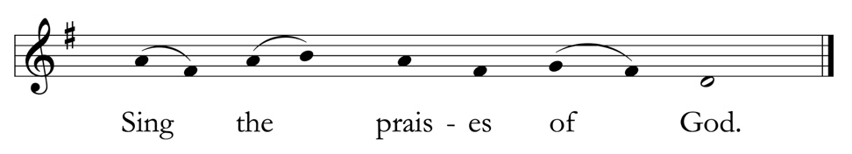
Cantor sings Refrain. All sing Refrain. Cantors sing verses.

Surely, it is God who saves me; I will trust in him and not be afraid.
For the Lord is my stronghold and my sure defense, and he will be my Savior.

All sing Refrain

Therefore you shall draw water with rejoicing from the springs of salvation.
And on that day you shall say, Give thanks to the Lord and call upon his Name;
Make his deeds known among the peoples; see that they remember that his Name is exalted.

All sing Refrain

Sing the praises of God, for he has done great things, and this is known in all the world.
Cry aloud, inhabitants of Zion, ring out your joy,
for the great one in the midst of you is the Holy One of Israel.

All sing Refrain

The Second Lesson 2 Thessalonians 3: 6-13
A reading from the Second Letter of Paul to the Church in Thessalonica

Now we command you, beloved, in the name of our Lord Jesus Christ, to keep away from believers who are living in idleness and not according to the tradition that they received from us. For you yourselves know how you ought to imitate us; we were not idle when we were with you, and we did not eat anyone's bread without paying for it; but with toil and labor we worked night and day, so that we might not burden any of you. This was not because we do not have that right, but in order to give you an example to imitate. For even when we were with you, we gave you this command: Anyone unwilling to work should not eat. For we hear that some of you are living in idleness, mere busybodies, not doing any work. Now such persons we command and exhort in the Lord Jesus Christ to do their work quietly and to earn their own living. Brothers and sisters, do not be weary in doing what is right.

After the reading, the reader says
Reader Hear what the Spirit is saying to God’s people.
People Thanks be to God.

Alleluia

Cantor sings Alleluia. All sing Alleluia.
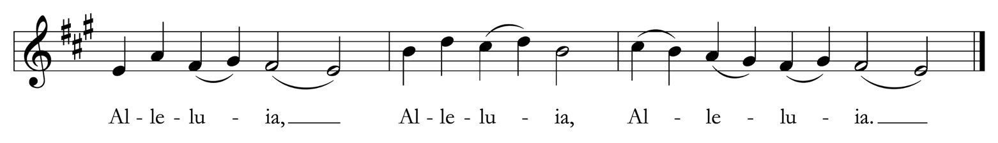

Cantor Brothers and sisters, do not be weary in doing what is right.

All sing Alleluia.

The Holy Gospel Luke 21: 5-19

Reader The Holy Gospel of our Lord Jesus Christ according to Luke.
People Glory to you, Lord Christ.
When some were speaking about the temple, how it was adorned with beautiful stones and gifts dedicated to God, Jesus said, "As for these things that you see, the days will come when not one stone will be left upon another; all will be thrown down."
They asked him, "Teacher, when will this be, and what will be the sign that this is about to take place?" And he said, "Beware that you are not led astray; for many will come in my name and say, `I am he!' and, `The time is near!' Do not go after them.
"When you hear of wars and insurrections, do not be terrified; for these things must take place first, but the end will not follow immediately." Then he said to them, "Nation will rise against nation, and kingdom against kingdom; there will be great earthquakes, and in various places famines and plagues; and there will be dreadful portents and great signs from heaven.
"But before all this occurs, they will arrest you and persecute you; they will hand you over to synagogues and prisons, and you will be brought before kings and governors because of my name. This will give you an opportunity to testify. So make up your minds not to prepare your defense in advance; for I will give you words and a wisdom that none of your opponents will be able to withstand or contradict. You will be betrayed even by parents and brothers, by relatives and friends; and they will put some of you to death. You will be hated by all because of my name. But not a hair of your head will perish. By your endurance you will gain your souls."

After the Gospel, the reader says
Reader The Gospel of the Lord.
People Praise to you, Lord Christ.

The people are seated.

Sermon Lincoln Elliott and Livi Ramseyer

All stand.
The Nicene Creed
We believe in one God,
the Father, the Almighty,
maker of heaven and earth,
of all that is, seen and unseen.

We believe in one Lord, Jesus Christ,
the only Son of God,
eternally begotten of the Father,
God from God, Light from Light,
true God from true God, begotten, not made, of one Being with the Father.
Through him all things were made.
For us and for our salvation he came down from heaven:
by the power of the Holy Spirit
he became incarnate from the Virgin Mary, and was made man.
For our sake he was crucified under Pontius Pilate;
he suffered death and was buried.
On the third day he rose again in accordance with the Scriptures;
he ascended into heaven and is seated at the right hand of the Father.
He will come again in glory to judge the living and the dead,
and his kingdom will have no end.
We believe in the Holy Spirit, the Lord, the giver of life,
who proceeds from the Father and the Son,
who with the Father and the Son is worshiped and glorified,
who has spoken through the prophets.
We believe in one holy catholic and apostolic Church.
We acknowledge one baptism for the forgiveness of sins.
We look for the resurrection of the dead,
and the life of the world to come. Amen.

The Prayers of the People Hear Our Prayer

Holy Lord, be among us, hear us, and fulfill the hope of our prayers as we say, Lord in your mercy, hear our prayer.

Bestow your grace upon your church and lend us your strength so that we might boldly proclaim and live out the good news of Jesus Christ. We especially lift up the Episcopal / Anglican Province of Alexandria in the Anglican Communion; St. Edmund’s, Pacifica in the Diocese of California.
Lord in your mercy, hear our prayer.

Shower wisdom on those who hold authority in our lives, that they might seek to lead through service to the greatest good.
Lord in your mercy, hear our prayer.

Embolden us to be the body of Christ in our local community, that our presence might be a pledge of our commitment to love our neighbors.
Lord in your mercy, hear our prayer.
Arouse in us the desire to protect and sustain your abundant creation, that our world may remain a place of wonder and sustenance for future generations.
Lord in your mercy, hear our prayer.

Bring your healing power to bear in the lives of all who endure illness or injury, that they may know peace, and arouse us to be the people of care and reconciliation. Especially we pray for Janet Bock, Rodney Gehrke, Homa, Michael Kimball, Ray Loughrey, Jen Norman, Jack Palladino, Janice Parsons, Linda Pittman, Jim Prescott, Parker Quickert, Carmen Villalobos, and those affected by mass shootings around the country.
Lord in your mercy, hear our prayer.

Take into your loving arms all those who have died that they might grow in love and devotion to you and bring us once again into the presence of those we have loved in your eternal kingdom. Especially we pray for Karen, Lucy Kovacich, Peter Kovacich, Vince Kovacich, and Lia Smith.
Lord in your mercy, hear our prayer.

Blessed Lord, you have longed for the turning of every human heart and have showed us in word and deed the path of promise that leads to you. Hear and answer our prayers, that we might see more fully, your kingdom and so that your glory might be reflected and magnified throughout the world. Amen.

The Confession

Let us confess our sins against God and our neighbor.

Silence may be kept.

God of all mercy,
we confess that we have sinned against you,
opposing your will in our lives.
We have denied your goodness in each other,
in ourselves, and in the world you have created.
We repent of the evil that enslaves us, the evil we have done,
and the evil done on our behalf.
Forgive, restore, and strengthen us through our Savior Jesus Christ,
that we may abide in your love and serve only your will. Amen.

The Absolution

Almighty God have mercy on you, forgive you all your sins through our Lord Jesus Christ, strengthen you in all goodness, and by the power of the Holy Spirit keep you in eternal life. Amen.

The Peace

Celebrant The Peace of Christ be always with you.
People And also with you.

The people greet each other with a sign of God's peace and then are seated.
Announcements

Offertory Sentence

Offertory Anthem And I saw a new heaven, Edgar L. Bainton (1880-1956)

And I saw a new heaven and a new earth:
For the first heaven and the first earth were passed away, and there was no more sea.
And I John saw the holy city, new Jerusalem, coming down from God out of heaven,
prepared as a bride adorned for her husband.

And I heard a great voice out of heaven, saying,
Behold, the tabernacle of God is with men, and he will dwell with them and they shall be his people,
and God himself shall be with them and be their God.

And God shall wipe away all tears from their eyes;
And there shall be no more death, neither sorrow nor crying,
neither shall there be any more pain, for the former things are passed away.
~ Revelation 21:1-4

All stand to sing

Presentation Hymn 454 “Jesus came, adored by angels,” Lowry

The Great Thanksgiving Eucharistic Prayer A, The Book of Common Prayer, page 361

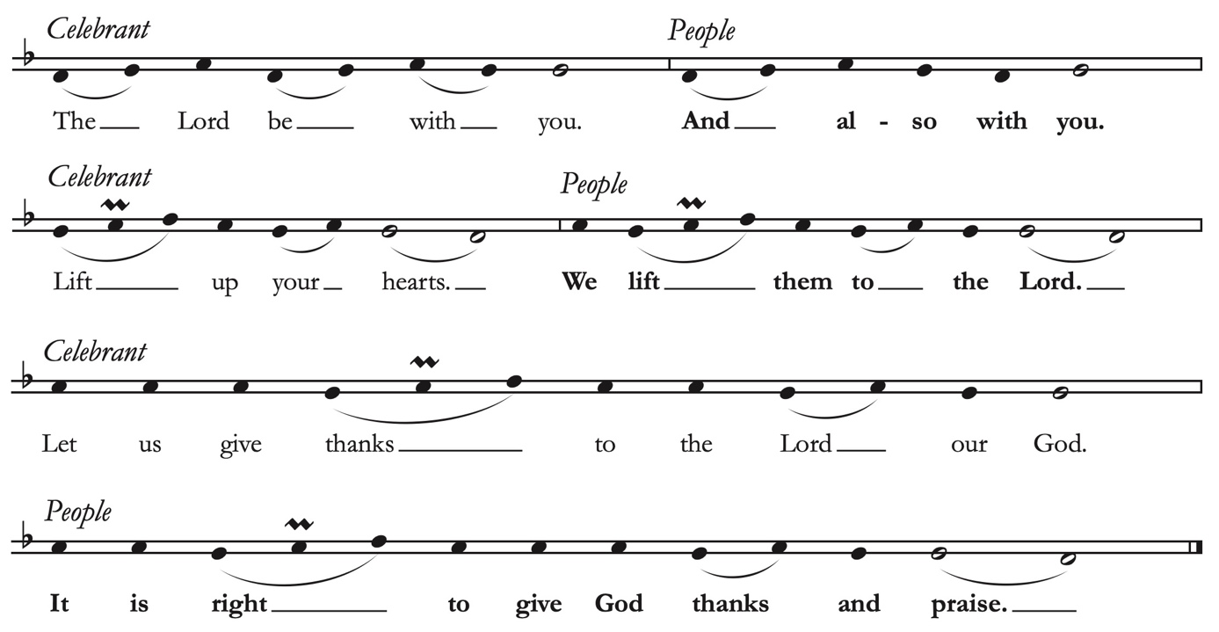

It is right, and a good and joyful thing, always and every where to give thanks to you, Almighty God, Creator of heaven and earth. For by water and the Holy Spirit you have made us a new people in Jesus Christ our Lord, to show forth your glory in all the world.
Therefore, joining with Angels and Archangels and with the faithful of every generation, we lift our voices with all creation as we sing:

Sanctus sung in Tongan by the choir The Book of Common Prayer, page 362

Ma’oni’oni, Ma’oni’oni, Ma’oni’oni, ‘E ‘Eiki, Koe ‘Otua ‘o e ngaahi kau tau,
‘oku fonu ‘a Hevani mo Mamanı ‘i ho naunau.
Gloria kiate koe, ‘E ‘Eiki Fungani Ma’olunga. Amen.
‘Oku monu’ia ia ‘oku ha’ele mai, ‘I he Huafa ‘o e ‘Eiki.
Hosana ‘i ‘olunga.

Holy, holy, holy Lord, God of power and might,
Heaven and earth are full of your glory. Hosanna in the highest.
Blessed is the one who comes in the name of the Lord.
Hosanna in the highest.

The Celebrant continues the Eucharistic Prayer, giving thanks for God’s work of redemption through Jesus Christ and consecrating the bread and wine for Holy Communion. The people join in sacramental witness, speaking to the mystery of God’s saving grace.

…Therefore we proclaim the mystery of faith:
Christ has died.
Christ is risen.
Christ will come again.

We celebrate the memorial of our redemption, Most Holy God, in this sacrifice of praise and thanksgiving. Recalling Christ’s death, resurrection, and ascension, we offer you these gifts.

Sanctify them by your Holy Spirit to be for your people the Body and Blood of your Son, the holy food and drink of new and unending life in Christ. Sanctify us also that we may faithfully receive this holy Sacrament, and serve you in unity, constancy, and peace; and at the last day bring us and all your saints into the joy of your eternal Reign.

All this we ask through your Son Jesus Christ: By whom, and with whom, and in whom, in the unity of the Holy Spirit all honor and glory are yours, Most Blessed One, now and forever. AMEN.

And now, as our Savior Christ has taught us, we are bold to say,
Our Father, who art in heaven, hallowed be thy Name,
thy kingdom come, thy will be done, on earth as it is in heaven.
Give us this day our daily bread.
And forgive us our trespasses, as we forgive those who trespass against us.
And lead us not into temptation, but deliver us from evil.
For thine is the kingdom, and the power, and the glory, for ever and ever. Amen.

The Breaking of the Bread
The Celebrant breaks the Bread. A period of silence is kept.

Alleluia! Christ our Passover is sacrificed for us.
Therefore let us keep the feast. Alleluia!

Invitation to Communion
The Celebrant lifts the bread and wine saying,
The gifts of God for the people of God. If you feel drawn to this table, let nothing keep you away.

All are welcome to receive Communion. Gluten-free wafers are available upon request. Ushers will see that Communion is brought to you at your seat, should you request it.

Communion Anthem The Darkest Hour (from Generations, 2023), Melissa Dunphy (b. 1980)
Soloists Mia Ayumi Malhotra, Victoria Chilcote, & Cornelia Ding

Today is always the darkest hour.
In it we behold: the fearful watchman, the crack of the whip, the covenant dusty and delayed.
Yet even in bleakest night, the nightingale sings, carrying the dreams of Moses and Aaron, Huerta and King.
We yearn with hands, we yearn with mouths, we yearn with marches and songs of praise.
God of our Forefathers, pardon our iniquity.
God of our Foremothers, marry love to strength, patience to resolve, hope to action.
Let us be a light in the darkness of our day.
~Jacqueline Goldfinger

Postcommunion Prayer
All stand as the Celebrant invites,
Let us pray.
God of abundance, you have fed us with the bread of life and cup of salvation; you have united us with Christ and one another; and you have made us one with all your people in heaven and on earth. Now send us forth in the power of your Spirit, that we may proclaim your redeeming love to the world and continue for ever in the risen life of Christ our Savior. Amen.

Blessing

Life is short,
And we do not have much time
to gladden the hearts of those who
make the journey with us.
So be swift to love,
and make haste to be kind.
And the blessing of God,
who made us, who loves us,
and who draws us into community by the power of the Spirit,
rest upon you and remain with you forever. Amen.

All sing
Hymn 597 “O day of peace,” Jerusalem

Dismissal
Following God’s saints in the ways of holiness and truth, go in the peace of Christ.
Thanks be to God.

Postlude Toccata in d (Dorian), BWV 538, Johann Sebastian Bach (1685-1750)

Copyright Acknowledgments. Reprinted under OneLicense.net #A-706347 and a Rite Song reprint license for congregational use.


St. Paul’s Episcopal Church • 415 El Camino Real, Burlingame • 650.348.4811 • www.stpaulsburlingame.org

