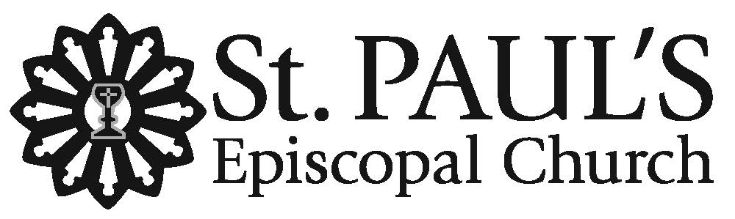
The Nativity of our
Lord Jesus Christ
Choral Eucharist
December 24, 2025 • 10pm

Welcome to St. Paul's! We are grateful you are worshiping with us on this holy night when we recall how God entered the world as a vulnerable babe. Children indeed are most welcome here. The order for tonight’s service is found in this leaflet. Music may be found in the blue Hymnal 1982 located in the pew rack. The people’s responses are indicated by bold type. Please do remember to silence your devices as our worship service begins.

Restrooms are located in the Parish Hall on the Occidental Avenue side of the church campus. Our worship service is live-streamed on St. Paul's YouTube Channel, where we welcome online friends to pray with us.
All are warmly invited to participate in Holy Communion at St. Paul’s. If you prefer not to receive the wine, simply cross your arms over your chest as the Eucharistic Minister greets you saying, “the Blood of Christ, the Cup of Salvation.” We wish you God’s comfort, peace, and joy this Christmas!

Prelude Concerto in F, HWV 295 (The Cuckoo and the Nightingale)
George Frideric Handel (1685-1759)

All stand following the chiming of the hour.

Hymn 102 “Once in royal David's city,” Irby
arr. David Willcocks

1 - Solo sung by a chorister from the high altar
2- Sung by choir from font, as chorister places Christ child in the Crêche
3, 6 – All sing

Blessing of the Crêche

O great mystery, and wonderful sacrament,
that animals should see the new-born Savior, lying in a manger!
Blessed is the womb that bore this Holy Child, Christ the Lord. Alleluia!

The Word was made flesh
And dwelt among us.

Let us pray. Almighty God, who in the Incarnation of your Son has revealed to us the holiness of creation, be pleased to bless this gentle setting of our Savior’s birth, so that those who gaze upon it may behold this mystery, whereby humanity shares in your very nature; through Christ our Lord. Amen.

All sing stanzas 1, 2, 3, & 6

Processional Hymn 83 “O come, all ye faithful,” Adeste fideles
arr. D. Willcocks
Opening Acclamation

Celebrant Word made flesh, Life of the world, in your incarnation you embraced our poverty:
People so that by your Spirit we might share in your riches. Amen.

Almighty God, to you all hearts are open, all desires known, and from you no secrets are hid: Cleanse the thoughts of our hearts by the inspiration of your Holy Spirit, that we may perfectly love you, and worthily magnify your holy Name; through Christ our Lord. Amen.

The people are seated.

Gloria sung by choir in Latin from Gloria, Antonio Vivaldi (1678-1741)

Gloria in excelsis Deo. Glory to God in the highest.
All stand.

The Collect of the Day

Celebrant The Lord be with you.
People And also with you.
Celebrant Let us pray.

A moment of silence is observed as we prepare our hearts for prayer.

Almighty God, you have given your only-begotten Son to take our nature upon him, and to be born of a pure virgin: Grant that we, who have been born again and made your children by adoption and grace, may daily be renewed by your Holy Spirit; through our Lord Jesus Christ, to whom with you and the same Spirit be honor and glory, now and for ever. Amen.

The people are seated.

The First Lesson Isaiah 9: 2-7

A reading from the Prophet Isaiah

The people who walked in darkness
have seen a great light;
those who lived in a land of deep darkness--
on them light has shined.
You have multiplied the nation,
you have increased its joy;
they rejoice before you
as with joy at the harvest,
as people exult when dividing plunder.
For the yoke of their burden,
and the bar across their shoulders,
the rod of their oppressor,
you have broken as on the day of Midian.
For all the boots of the tramping warriors
and all the garments rolled in blood
shall be burned as fuel for the fire.
For a child has been born for us,
a son given to us;
authority rests upon his shoulders;
and he is named
Wonderful Counselor, Mighty God,
Everlasting Father, Prince of Peace.
His authority shall grow continually,
and there shall be endless peace
for the throne of David and his kingdom.
He will establish and uphold it
with justice and with righteousness
from this time onward and forevermore.
The zeal of the Lord of hosts will do this.

After the reading, the reader says

Reader Hear what the Spirit is saying to God’s people.
People Thanks be to God.

All stand to sing.

Hymn 82 “Of the Father’s love begotten,” Divinum mysterium

1 – All; 2 – Lower Voices; 3 – Upper Voices; 4 - All

The people are seated.

The Second Lesson Titus 2: 11-14

A reading from the Book of Titus

For the grace of God has appeared, bringing salvation to all, training us to renounce impiety and worldly passions, and in the present age to live lives that are self-controlled, upright, and godly,
while we wait for the blessed hope and the manifestation of the glory of our great God and Savior, Jesus Christ. He it is who gave himself for us that he might redeem us from all iniquity and purify for himself a people of his own who are zealous for good deeds.

After the reading, the reader says

Reader Hear what the Spirit is saying to God’s people.
People Thanks be to God.

All stand to sing.

Alleluia Verse Chant, based on the O Antiphons
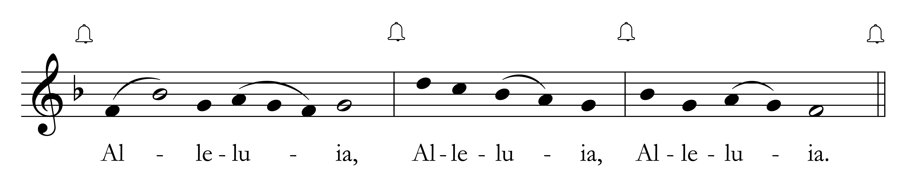
Cantor sings Alleluia. All sing Alleluia.

Cantor: For a child has been born for us, a son given to us;
and he is named Wonderful Counselor, Mighty God, Everlasting Father, Prince of Peace.

All sing Alleluia.

The Holy Gospel Luke 2: 1-20

Reader The Holy Gospel of our Lord Jesus Christ according to Luke.
People Glory to you, Lord Christ.

In those days a decree went out from Emperor Augustus that all the world should be registered. This was the first registration and was taken while Quirinius was governor of Syria. All went to their own towns to be registered. Joseph also went from the town of Nazareth in Galilee to Judea, to the city of David called Bethlehem, because he was descended from the house and family of David. He went to be registered with Mary, to whom he was engaged and who was expecting a child. While they were there, the time came for her to deliver her child. And she gave birth to her firstborn son and wrapped him in bands of cloth, and laid him in a manger, because there was no place for them in the inn.
In that region there were shepherds living in the fields, keeping watch over their flock by night. Then an angel of the Lord stood before them, and the glory of the Lord shone around them, and they were terrified. But the angel said to them, “Do not be afraid; for see – I am bringing you good news of great joy for all the people: to you is born this day in the city of David a Savior, who is the Messiah, the Lord. This will be a sign for you: you will find a child wrapped in bands of cloth and lying in a manger.” And suddenly there was with the angel a multitude of the heavenly host, praising God and saying, “Glory to God in the highest heaven, and on earth peace among those whom he favors!”
When the angels had left them and gone into heaven, the shepherds said to one another, “Let us go now to Bethlehem and see this thing that has taken place, which the Lord has made known to us.” So they went with haste and found Mary and Joseph, and the child lying in the manger.
When they saw this, they made known what had been told them about this child; and all who heard it were amazed at what the shepherds told them. But Mary treasured all these words and pondered them in her heart. The shepherds returned, glorifying and praising God for all they had heard and seen, as it had been told them.
Reader The Gospel of the Lord.
People Praise to you, Lord Christ.

The people are seated.

The Sermon The Rev. Sarah C. Stewart

The Nicene Creed

Said by all, standing.

We believe in one God,
the Father, the Almighty,
maker of heaven and earth, of all that is, seen and unseen.

We believe in one Lord, Jesus Christ,
the only Son of God,
eternally begotten of the Father, God from God, Light from Light,
true God from true God, begotten, not made, of one Being with the Father.
Through him all things were made.
For us and for our salvation he came down from heaven;
by the power of the Holy Spirit
he became incarnate from the Virgin Mary, and was made man.
For our sake he was crucified under Pontius Pilate;
he suffered death and was buried.
On the third day he rose again in accordance with the Scriptures;
he ascended into heaven and is seated at the right hand of the Father.
He will come again in glory to judge the living and the dead,
and his kingdom will have no end.

We believe in the Holy Spirit, the Lord, the giver of life,
who proceeds from the Father and the Son.
Who with the Father and the Son is worshipped and glorified.
Who has spoken through the Prophets.
We believe in one holy catholic and apostolic Church.
We acknowledge one baptism for the forgiveness of sins.
We look for the resurrection of the dead,
and the life of the world to come. Amen.

The Prayers of the People

Let us pray: God of darkness and silence, you have pierced the quiet of this night
by the utterance of your Word made flesh.
May your word of compassion and reconciliation resound in us and through us.

In this holy night, angels proclaimed the peace of your unconquered Son of righteousness.
Strengthen all who work for peace and justice.

In this holy night, you came to us in a child cradled in a borrowed bed of straw
as there was no room in the inn.
Open our hearts to the needs of the homeless and the hungry.

In this holy night, shepherds and outcasts heard your good news.
Give us grace to receive your gospel of joy and liberation.

In this holy night, we rejoice at the coming of this time of re-creation.
Be with those who travel, renew our rejoicing, and strengthen loving bonds between us.

In this holy night, Christians throughout the world are celebrating Christ’s birth.
Unite us in one family that your true light might scatter all our darkness.

In this holy night, your living Word leaped down, shedding light on all who dwell in darkness
and in the shadow of death.
Give strength and peace to all who suffer in body, mind, or spirit.

In this holy night, you give us power to be your children.
Fulfill your love to all who have gone before us in the faith.
May we, like them, embrace the mystery of the Word made flesh
and dwell joyfully in the grace your eternal presence.

In the stillness of this night, I invite you to pray silently or aloud for those in need of Christ’s
healing love and redeeming light.

Prayers are offered by those in the congregation.

The Celebrant concludes the prayers with,

Holy One, hear these prayers we bring to you and fulfill your purposes in us through the love of Jesus, your Incarnate Word. Amen.

The Peace

Celebrant The peace of Christ be always with you.
People And also with you.

The people greet each other with a sign of God’s peace and then are seated.

Announcements and Offertory Sentence

The Holy Communion

Offertory Anthem In the bleak midwinter, Harold Darke (1888-1976)

In the bleak midwinter, frosty wind made moan. Earth stood hard as iron, water like a stone.
Snow had fallen snow on snow, Snow on snow, in the bleak midwinter long ago.

Our God, Heav’n cannot hold Him, nor earth sustain.
Heav’n and earth shall flee away when He comes to reign.
In the bleak midwinter, a stable place sufficed the Lord God Almighty, Jesus Christ.

Enough for Him, whom cherubim, worship night and day. A breast full of milk, and a mangerful of hay.
Enough for Him, whom angels, fall down before. The ox and ass and camel, which adore.

What can I give Him, poor as I am? If I were a shepherd, I would bring a lamb.
If I were a wise man, I would do my part. Yet what can I give Him, give my heart.

~ Christina Rossetti (1830-1894)
All stand to sing.

Hymn 91 “Break forth, O beauteous heavenly light,” Brich an, o schönes Morgenlicht

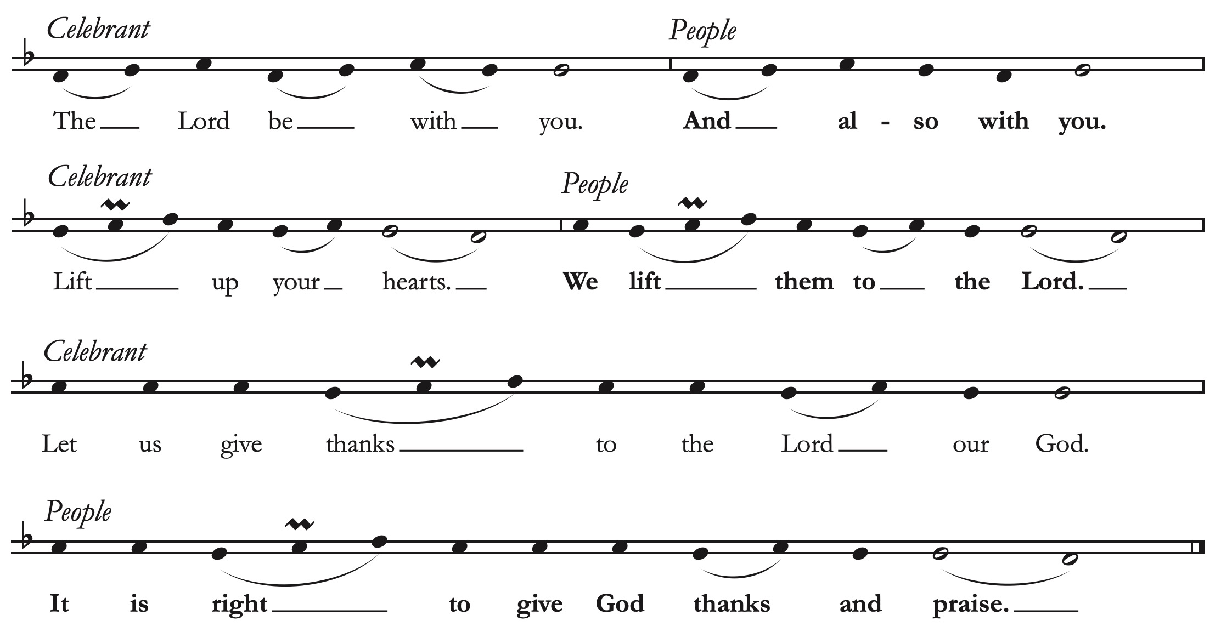
The Great Thanksgiving Eucharistic Prayer B, The Book of Common Prayer, p. 367
The Celebrant continues with the proper preface.

Sanctus sung by choir in Latin Messe de Minuit pour Noël, Marc-Antoine Charpentier (1643-1704)

Sanctus, Sanctus, Sanctus,
Dominus Deus Sabaoth.
Pleni sunt caeli et terra gloria tua.
Hosanna in excelsis.
Holy, Holy, Holy,
Lord God of Hosts.
Heaven and earth are full of thy glory.
Hosanna in the highest.

The people stand or kneel, as the Celebrant continues the Eucharistic Prayer,

We give thanks to you, O God, for the goodness and love which you have made known to us in creation; in the calling of Israel to be your people; in your Word spoken through the prophets; and above all in the Word made flesh, Jesus, your Son. For in these last days you sent him to be incarnate from the Virgin Mary, to be the Savior and Redeemer of the world. In him, you have delivered us from evil, and made us worthy to stand before you. In him, you have brought us out of error into truth, out of sin into righteousness, out of death into life.

On the night before he died for us, our Savior Jesus Christ took bread; and when he had given thanks to you, he broke it, and gave it to his disciples, and said, “Take, eat: This is my Body,
which is given for you. Do this for the remembrance of me.” After supper he took the cup of wine; and when he had given thanks, he gave it to them, and said, “Drink this, all of you: This is my Blood of the new Covenant, which is poured out for you and for all for the forgiveness of sins. Whenever you drink it, do this for the remembrance of me.”

Therefore, according to his command, Almighty God,

We remember his death,
We proclaim his resurrection,
We await his coming in glory;

The Celebrant continues,
And we offer our sacrifice of praise and thanksgiving to you, O Savior of all; presenting to you, from your creation, this bread and this wine.

We pray you, gracious God, to send your Holy Spirit upon these gifts that they may be the Sacrament of the Body of Christ and his Blood of the new Covenant. Unite us to your Son in his sacrifice, that we may be acceptable through him, being sanctified by the Holy Spirit. In the fullness of time, put all things in subjection under your Christ, and bring us to that heavenly country where, with all your saints, we may enter the everlasting heritage of your children; through Jesus Christ our Savior, the firstborn of all creation, the head of the Church, and the author of our salvation.

By whom, and with whom, and in whom, in the unity of the Holy Spirit all honor and glory is yours, Most Blessed One, now and for ever. AMEN.

As our Savior Christ has taught us, we are bold to pray:

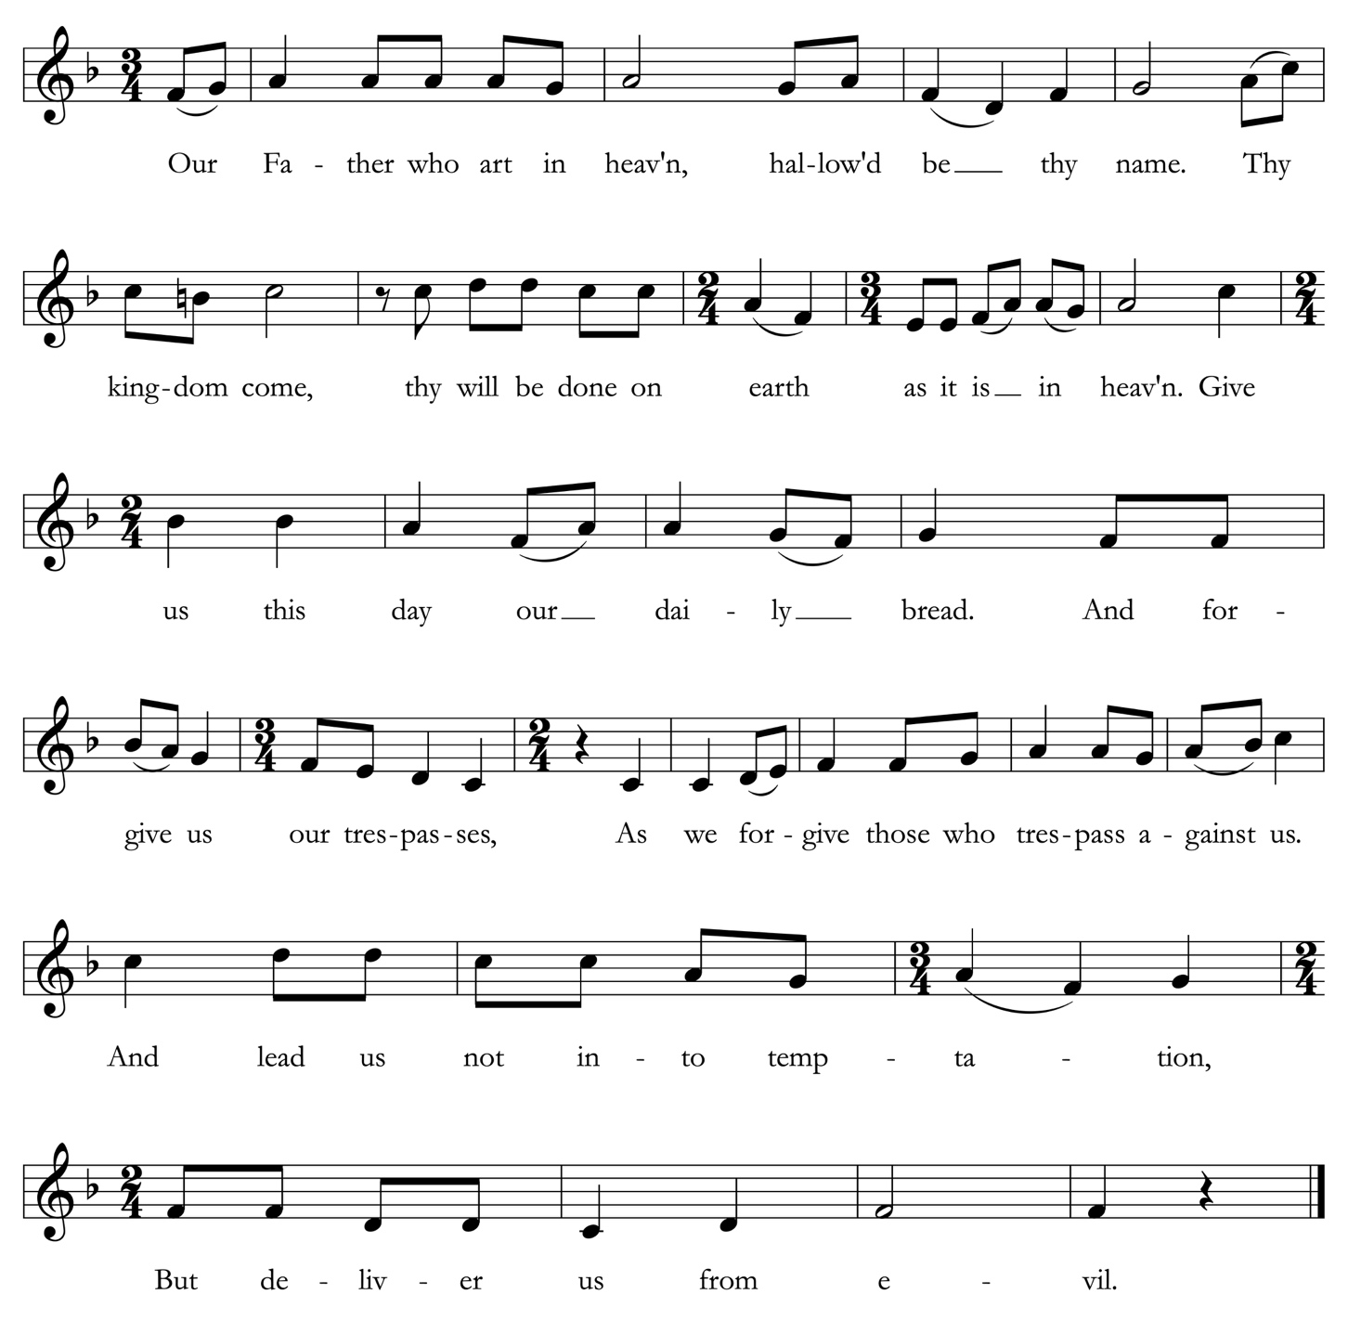
The Lord’s Prayer All are invited to sing. Maurice Duruflé (1902-1986)
The Breaking of the Bread
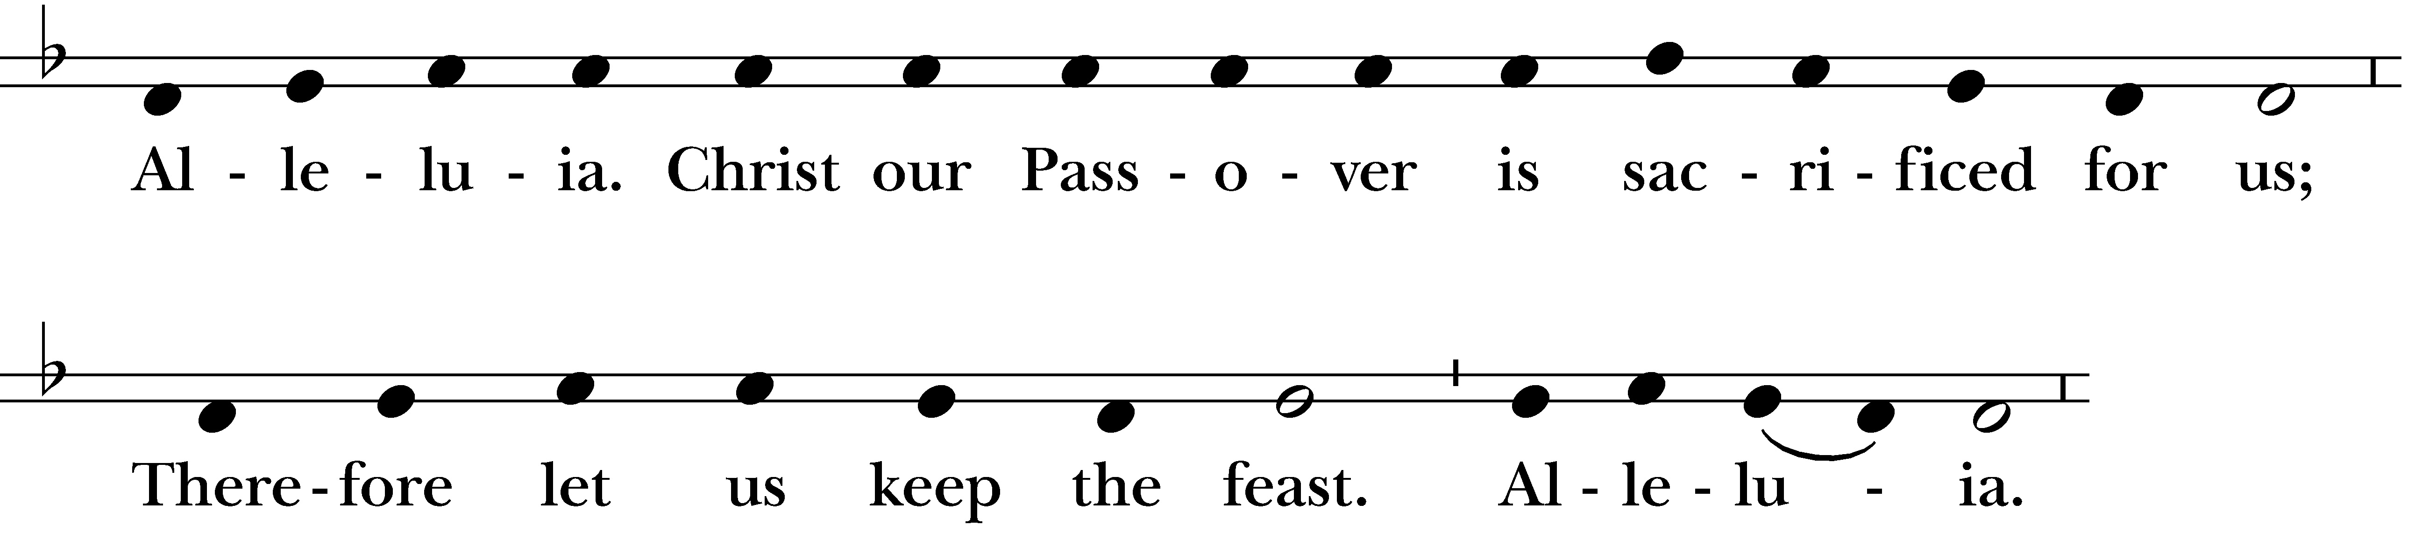
The Celebrant breaks the bread. A period of silence is kept.
Celebrant

All

Invitation to Communion

The Table is ready. So come, you who have much faith and you who would like to have more; you who have been here often and you who have not been for a long time; you who have tried to follow Jesus, and you who have failed. Come, because it is Christ who invites us to meet God here.

All who are drawn to Christ are welcome to receive communion at St. Paul's. Please follow the usher’s invitation to receive the bread (gluten free wafers available upon request) and wine at the altar rails. If you would like a blessing instead of the Eucharist, please cross your arms over your chest.

Music at Communion

Agnus Dei sung by choir in Latin Messe de Minuit pour Noël, Marc-Antoine Charpentier

Agnus Dei, qui tollis peccata mundi, miserere nobis.
Agnus Dei, qui tollis peccata mundi: dona nobis pacem.
Lamb of God, who takes away the sins of the world, have mercy upon us.
Lamb of God, that takes away the sins of the world, grant us peace.

Anthem sung by choir in Welsh Suo Gân, Welsh lullaby, arr. Stephen Cleobury

Sleep child upon my bosom
It is cozy and warm;
Mother's arms are tight around you,
A mother's love is in my breast;
Nothing shall disturb your slumber,
Nobody will do you harm;
Sleep in peace, dear child,
Sleep quietly on your mother's breast.
Sleep peacefully tonight, sleep;
Gently sleep, my lovely;
Why are you now smiling,
Smiling gently in your sleep?
Are angels above smiling on you,
As you smile cheerfully,
Smiling back and sleeping,
Sleeping quietly on my breast?

Do not fear, it is nothing but a leaf
Beating, beating on the door;
Do not fear, only a small wave
Murmurs, murmurs on the seashore;
Sleep child, there's nothing here
Nothing to give you fright;
Smile quietly in my bosom,
At the blessed angels yonder.

All kneel as able following communion. Acolytes begin the lighting of the people’s candles.

Hymn 111 “Silent Night,” Stille Nacht
The choir sings first in German:

Stille Nacht! heilige Nacht!
Alles schläft, einsam wacht
nur das traute hochheilige Paar.
Holder Knabe im lockigen Haar,
schlaf in himmlischer Ruh.’

All then sing.

1 Silent night, holy night,
all is calm, all is bright
round yon virgin mother and child.
Holy infant, so tender and mild,
Sleep in heavenly peace.
Sleep in heavenly peace.

2 Silent night, holy night,
shepherds quake at the sight,
glories stream from heaven afar,
heavenly hosts sing alleluia;
Christ, the Savior, is born!
Christ, the Savior, is born!

3 Silent night, holy night,
Son of God, love’s pure light
radiant beams from thy holy face,
with the dawn of redeeming grace,
Jesus, Lord, at thy birth.
Jesus, Lord, at thy birth.

All stand.

The Blessing
May Almighty God, who sent his Son to take our nature upon him, bless you in this holy season, scatter the darkness of sin, and brighten your heart with the light of his holiness.

May God, who sent his angels to proclaim the glad news of the Savior’s birth, fill you with joy,
and make you heralds of the Gospel.

May God, who in the Word made flesh joined heaven to earth and earth to heaven,
give you his peace and favor.

And the blessing of God Almighty, the Father, the Son, and the Holy Spirit, be upon you and remain with you for ever. Amen.

The people extinguish their candles.

All sing.
Hymn 87 “Hark! the herald angels sing,” Mendelssohn
arr. D. Willcocks
The Dismissal

Celebrant Go in peace to love and serve the Lord. Alleluia, alleluia!
People Thanks be to God. Alleluia, alleluia!

All remain standing until the procession has departed.
Postlude I. Allegro from Concerto for Violin and Organ in F Major, RV 542, Antonio Vivaldi

Copyright Acknowledgments. Reprinted under OneLicense.net #A-706347 and a Rite Song reprint license for congregational use.
CHRISTMAS FLOWER & MUSIC DEDICATIONS
With gratitude and appreciation, St. Paul’s thanks all who contributed
to the special music and flowers for this year’s commemoration of the Feast of the Incarnation.

Leslie Smith
With love and gratitude
for the blessings of my children and grandchildren;
Trevor Lewellen; Victor, Addison, Diego
and Elena Gaitan

✠

Tish and Jim Busselle
In gratitude for St. Paul’s community

✠

Anne Casscells & Susan Ketcham
In honor of Susan’s mom, Bunty Ketcham

✠

Tom and Cyndy Bodenlos
Merry Christmas to the St. Paul’s community

✠

The Rev. Sarah C. Stewart
With gratitude for the dedication and care
of St. Paul's Vestry, Ministry Leaders,
and Staff & prayers for God’s peace and joy
to bless our whole community this Christmas!

✠

The Culatana / Ding Family
In memory of Felix Y. Feng

Cisca Hansen
To the Glory of God and in thanksgiving

✠

Jenny Lau
For the loving memory of Andrew

✠

Ann Lowry and John A. Perez
In memory of Mary and Robert N. Lowry

✠

Sandy Galindo & Family
In memory of Raul Galindo & June Castelli – always in our hearts

✠

Sandy Galindo
To Rev. Sarah+ & my church family for all your love and support in this trying year

✠

Susan Jane Matthews
Merry Christmas to the Choir of St. Paul’s!

✠

Candace and James Martin
Remembering loved ones past and present

✠
Pat Ko
Ministers of worship

Altar Guild: Michelle Bosschart, Edith Foothorap
Communion Bread: Kathy Martin
Greeters & Ushers: Ron Goerss, Dean Scholl
Acolyte: Lucy Kendall, Vilson Marangco
Lectors: Bev Hock, Bill Phillips, Raya Illieva
Cup Bearers: Jocelyn A. Sideco, Bill Phillips
A/V: James Martin
Celebrant & Preacher: The Rev. Sarah C. Stewart
Priest Associate: The Rev. Nick W. Roosevelt
Assistant: Ms. Jocelyn A. Sideco, MTS

Musicians:
The Choir of St. Paul’s
Susan Jane Matthews, Director

Soprano  Cyndy Bodenlos  Victoria Chilcote  Marian Chin  Janet Gehrke  Jo Ann Hartley  **Lily Hartley  *Ruby Kendall  Susan Ketcham  Anita van Kimmenade  Sydney Kropf  **Séraphée de Labaca  *Anna Malhotra  Mia Malhotra  **Sophia Subramanian | Alto  **Joey Blundell  Anne Casscells  Barb Dedo  Elizabeth Kendall  Pat Ko  Gail Nezvigin | Tenor  Paul Hoerbelt  **Gabriel Lim  Scott Power  David Kurtenbach Rivera  Bass  Josh Black  *Dmitri Nezvigin  Ari Nieh  *Choir School  **Choir School alumni

Iris Stone, Rebecca Wishnia, violin
Sandy Leem, viola
Eric Gaenslen, cello
Michel Taddei, double bass
Adrienne Burg, Allison Gessner, oboe
Chase Olson, organ



St. Paul’s Episcopal Church • 415 El Camino Real Burlingame, CA 94010 • 650.348.4811 www.stpaulsburlingame.org

