
The Nativity of our
Lord Jesus Christ
Christmas Pageant
December 24, 2025 • 4pm

Welcome to St. Paul's! We are grateful you are worshiping with us on this holy night when we recall how God entered the world as a vulnerable babe. Children indeed are most welcome here. The order for tonight’s service is found in this leaflet, along with the texts for all hymns. Music may be found in the blue Hymnal 1982 located in the pew rack. The people’s responses are indicated by bold type. Please silence your devices as our worship service begins.

Restrooms are located in the Parish Hall on the Occidental Avenue side of the church campus. Our worship service is live-streamed on St. Paul's YouTube Channel, where we welcome online friends to pray with us.
All are warmly invited to participate in Holy Communion at St. Paul’s. If you prefer not to receive the wine, simply cross your arms over your chest as the Eucharistic Minister greets you saying, “the Blood of Christ, the Cup of Salvation.” We wish you God’s comfort, peace, and joy this Christmas!

Please refrain from photography/videography during the Pageant. Thank you for your care!

Prelude Noël Grand Jeu et Duo, Louis-Claude d’Aquin (1694-1772)

Welcome The Rev. Sarah C. Stewart, Rector of St. Paul’s

All stand.

Celebrant The people who have walked in darkness
People have seen a great light.

Celebrant For unto us a child is born
People unto us a child is given.

Celebrant Glory to God in the highest
People and peace to God’s people on earth!

The Collect of the Day
Celebrant The Lord be with you.
People And also with you.
Celebrant Let us pray.

A moment of silence is observed as we prepare our hearts for prayer.

Almighty God, as we prepare with joy to celebrate the gift of the Christ-child, embrace the earth with your glory and be for us a living hope in Jesus Christ our Lord. Amen.

All remain standing.

The Nativity Pageant

Hymn 102 stanzas 1, 2 & 3 “Once in royal David’s city,” Irby

The choir sings.

1. Once in royal David’s city stood a lowly cattle shed,
where a mother laid her baby in a manger for his bed:
Mary was that mother mild, Jesus Christ her little child.

All sing.

2. He came down to earth from heaven, who is God and Lord of all,
and his shelter was a stable, and his cradle was a stall;
with the poor, the scorned, the lowly, lived on earth our Savior holy.

3. We, like Mary, rest confounded that a stable should display
heaven’s Word, the world’s creator, cradled there on Christmas Day,
yet this child, our Lord and brother, brought us love for one another.

The people are seated.

***

Scene I The Birth of John the Baptist Foretold Luke 1: 5-24

All stand to sing.

Hymn 65 stanzas 1 & 2 “Prepare the way, O Zion,” Bereden väg för Herran

1. Prepare the way, O Zion, your Christ is drawing near!
Let every hill and valley a level way appear.
Greet one who comes in glory, foretold in sacred story.
Oh, blest is Christ that came in God’s most holy name.

2. He brings God’s rule, O Zion; he comes from heaven above.
His rule is peace and freedom, and justice, truth, and love.
Lift high your praise resounding, for grace and joy abounding.
Oh, blest is Christ that came in God’s most holy name.

The people are seated.

Scene II The Annunciation Luke 1: 26-38

Choir Ave Maria, Fanny Hensel

***

Scene III Joseph’s Dream Matthew 1: 18-25

Choir The Cherry Tree Carol, English carol, arr. June Nixon

Joseph was an old man
and an old man was he,
When he wedded Mary, in the land of Galilee.

And as they were walking
through an orchard so good,
Where was cherries and berries,
so red as any blood.

O then bespoke Mary,
with words both meek and mild:
‘Pluck me one cherry, Joseph
for I am great with child.’

Go to the tree then,
Mary, and it shall bow to thee:
And you shall gather cherries
by one, by two, by three.

Then bowed down the highest tree
unto our Lady’s hand;
‘See, see Joseph, I have cherries at command.’

O eat your cherries, Mary,
O eat your cherries now;
O eat your cherries, Mary,
that grow upon the bough.

Then Mary plucked a cherry,
as red as any blood,
Then Mary she went homeward
all with her heavy load.

All stand to sing.

Hymn 78 stanzas 1 & 5 “O little town of Bethlehem,” Forest Green

1. O little town of Bethlehem, how still we see thee lie!
Above thy deep and dreamless sleep the silent stars go by;
yet in thy dark streets shineth the everlasting Light;
the hopes and fears of all the years are met in thee tonight.

5. O holy Child of Bethlehem, descend to us, we pray;
cast out our sin and enter in, be born in us today.
We hear the Christmas angels the great glad tidings tell;
O come to us, abide with us, our Lord Emmanuel!

The people are seated.

***
Scene IV The Decree Luke 2: 1-7

Centurion and the Israelite Centurion Song (from The Christmas Jazz), Herbert Chappell

All stand to sing.

Hymn 101 stanzas 1 & 2 “Away in a manger,” Cradle song
1. Away in a manger, no crib for his bed,
the little Lord Jesus laid down his sweet head.
The stars in the bright sky looked down where he lay,
The little Lord Jesus asleep on the hay.

2. The cattle are lowing, the baby awakes,
but little Lord Jesus no crying he makes.
I love thee, Lord Jesus! Look down from the sky,
And stay by my side until morning is nigh.

The people are seated.

***
Scene V The Shepherds & the Angels Luke 2: 8-18

Choir Gloria Ding Dong! Merrily on High, Charles Wood

Procession of Animals, Little Shepherds and Angels to the Manger

All children are invited to process forward to visit the Baby Jesus.

Flute Bring a torch, Jeannette Isabella, French Carol
Choir sung in Welsh Suo Gân, Welsh lullaby

All stand to sing.

Hymn 83 stanzas 1 & 3 “O come, all ye faithful,” Adeste fideles

1 O come, all ye faithful,
joyful and triumphant,
O come ye, O come ye to Bethlehem;
come, and behold him,
born the King of angels;
O come, let us adore him,
O come, let us adore him,
O come, let us adore him,
Christ the Lord.
3 Sing, choirs of angels,
sing in exultation,
sing, all ye citizens of heaven above;
glory to God,
glory in the highest;
O come, let us adore him,
O come, let us adore him,
O come, let us adore him,
Christ the Lord.

The people are seated. Children remain in the chancel area for the sermon.

The Children’s Sermon The Rev. Sarah C. Stewart

All stand.

The Peace
Celebrant The peace of Christ be always with you.
People And also with you.

The people greet each other with a sign of God’s peace.

Children return to sit with their families. Choristers continue to sing Offertory Anthem. All are seated.

Announcements

Offertory Sentence

The Holy Communion

Offertory Anthem Aria from Gloria, Antonio Vivaldi (1678-1741)

Domine Deus, Rex coelestis, Deus Pater omnipotens.
Lord God, Heavenly King, God the Father almighty.

All stand to sing.

Presentation Hymn 100 “Joy to the World,” Antioch

1 Joy to the world! the Lord is come:
let earth receive her King;
let every heart prepare him room,
and heaven and nature sing.

2 Joy to the world! the Savior reigns;
let us our songs employ,
while fields and floods, rocks,
hills and plains, repeat the sounding joy.
3 No more let sins and sorrows grow,
nor thorns infest the ground;
he comes to make his blessings flow
far as the curse is found.

4 He rules the world with truth and grace,
and makes the nations prove
the glories of his righteousness,
and wonders of his love.

The Great Thanksgiving

Celebrant The Lord be with you.
People And also with you.

Celebrant Lift up your hearts.
People We lift them up to the Lord.

Celebrant Let us give thanks to the Lord our God.
People It is right to give God thanks and praise.

In the beginning, God made the world and everything in it with love. God made us to share God’s life and to care for creation. Our whole world, our whole lives are gifts from God. We give thanks to God for everything good. For the parts of life that bring us joy and Jesus’ call to love each other.

When we are sad, we remember God is with us. When we make mistakes and hurt each other, we are relieved to learn that God forgives us, and God helps us to forgive each other. So, with all God’s people around the world, and even with angels in earth and in heaven, we sing this song of thanks and praise:

All sing.
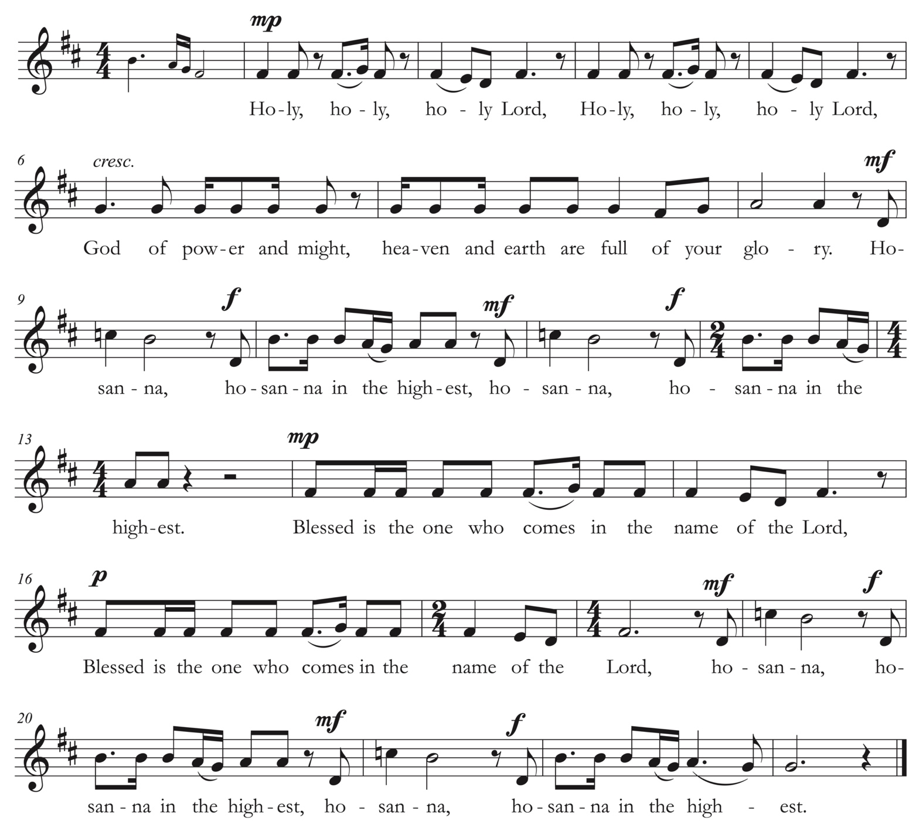
Sanctus The St. Helen’s Service, Joanna Forbes L’Estrange

Tonight, we remember God has always loved us. We tell the amazing story of how God chose to come even closer to help us, to live with us, to show us how to love each other.

God was born like a baby is born, and his parents named him Jesus. Jesus connected with everybody, even those who didn’t like him. Some people didn’t understand this and they became angry.

They wanted to hurt Jesus; they even wanted to kill him. Jesus saw this would bring trouble. So he had one last special dinner with his friends. Jesus took the bread they were eating, and he gave thanks to God.

Jesus broke the bread, and gave it to his friends, and said, “Take, eat: This is my Body, which is given for you. Do this for the remembrance of me.”

As supper was ending, Jesus took a cup of wine. When he had given thanks to God, he gave it to his friends, and said, “Drink this, all of you: This is my Blood, which is a new promise. I give my life for you and for all people to forgive all sins. Whenever you drink it, do this for the remembrance of me.”

Loving God, remembering how Jesus suffered and died, and proclaiming that Jesus rose again; that he went up to heaven so that he could help us all remember we all are members of your family, your beloved children, we bring you these gifts, like he taught us.

Make them holy by your Spirit, to be for us, your people, the Body and Blood of Christ. And send your Holy Spirit to bless us. As we share this holy meal, make us one body, to be the hands and feet of Jesus on this earth.

By whom and with whom and in whom, in the unity of the Holy Spirit, all honor and glory is yours, Almighty God, now and forever. AMEN.

Just like Jesus taught his friends, we now pray,

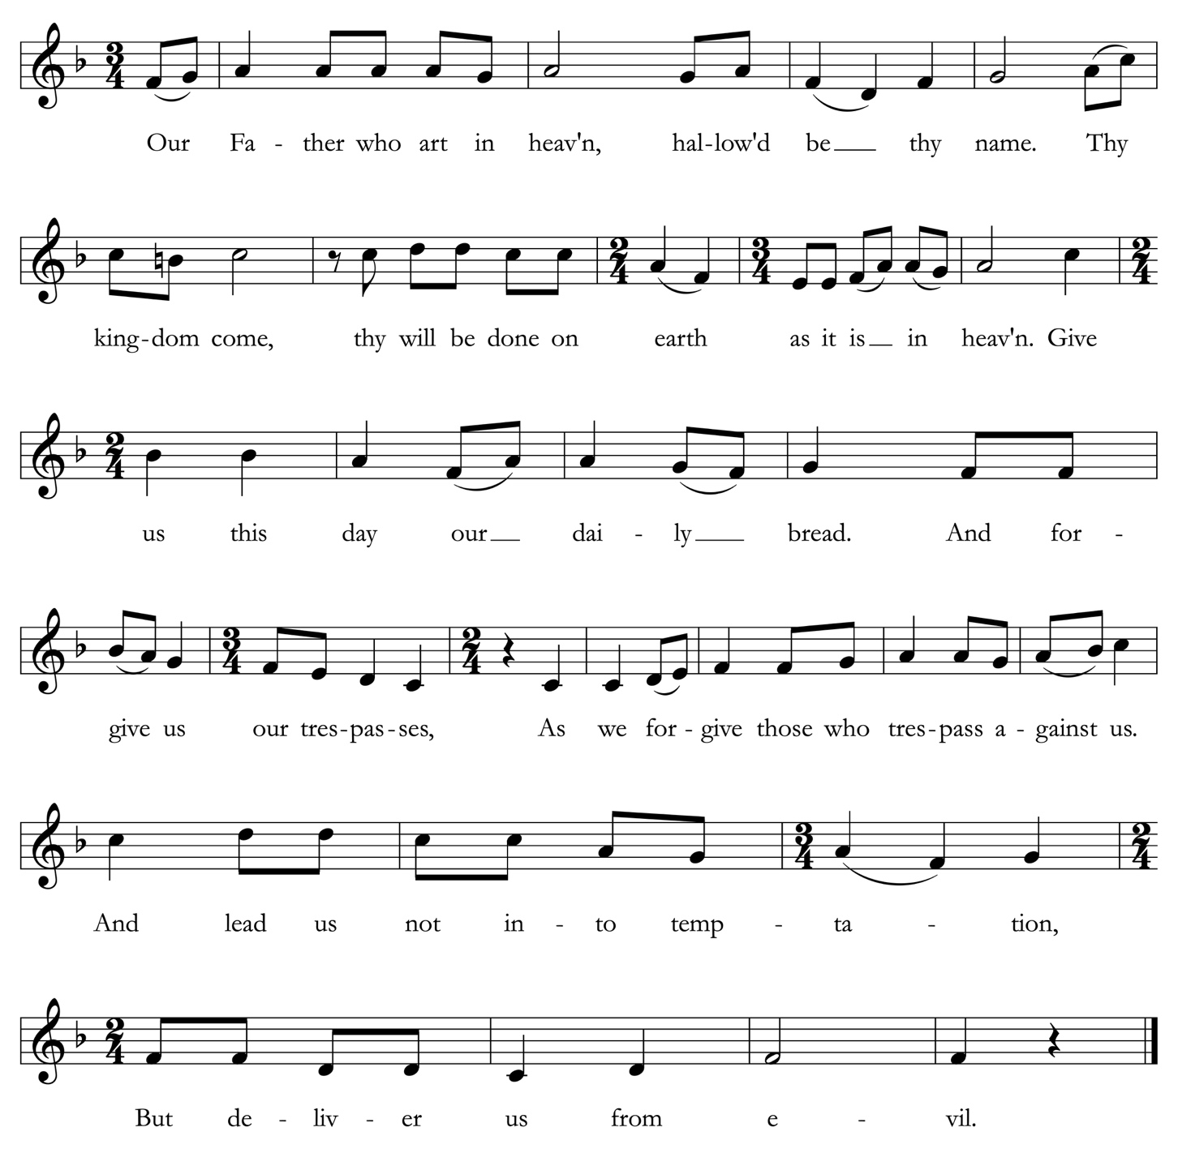
The Lord’s Prayer All are invited to sing. Maurice Duruflé (1902-1986)

The Breaking of the Bread

The Celebrant breaks the bread. A period of silence is kept.

Celebrant Alleluia. Christ our Passover is sacrificed for us;
People Therefore let us keep the feast. Alleluia.

Celebrant These are God’s gifts, given in love.
With grateful hearts and hands that bless, let us celebrate this holy feast.
Welcomed in love are all who share God’s grace at this table.
The Gifts of God for the People of God

All are welcome to receive communion at St. Paul’s. If you would like a blessing instead of bread, place your hands across your heart. Gluten-free communion is available. Ushers will see that Communion is brought to you, should you request it.
Music at Communion Sonata for Flute in E Major, BWV 1035, Johann Sebastian Bach (1685-1750)
Following communion, acolytes begin the lighting of the people’s candles.

The people remain seated to sing.

Hymn 111 “Silent Night,” Stille Nacht

1 Silent night, holy night,
all is calm, all is bright
round yon virgin mother and child.
Holy infant, so tender and mild,
Sleep in heavenly peace.
Sleep in heavenly peace.
2 Silent night, holy night,
shepherds quake at the sight,
glories stream from heaven afar,
heavenly hosts sing alleluia;
Christ, the Savior, is born!
Christ, the Savior, is born!

3 Silent night, holy night,
Son of God, love’s pure light
radiant beams from thy holy face,
with the dawn of redeeming grace,
Jesus, Lord, at thy birth.
Jesus, Lord, at thy birth.

All stand.

The Blessing

May the joy of the angels,
the eagerness of the shepherds,
the trust of the magi,
the courage of Joseph and Mary,
and the peace of the Christ-child
be yours this Christmas;
and the blessing of God Almighty,
Creator, Son, and Holy Spirit
rest upon you and remain with you for ever. Amen.

The people extinguish their candles.

All sing.

Hymn 87 “Hark! the herald angels sing,” Mendelssohn

1 Hark! the herald angels sing
glory to the newborn King!
Peace on earth and mercy mild,
God and sinners reconciled!
Joyful, all ye nations, rise,
join the triumph of the skies;
with the angelic host proclaim
Christ is born in Bethlehem!
Hark! the herald angels sing
glory to the newborn King!

2 Christ, by highest heaven adored;
Christ, the everlasting Lord;
late in time behold him come,
offspring of the Virgin’s womb.
Veiled in flesh the Godhead see;
hail the incarnate Deity.
Pleased as man with man to dwell;
Jesus, our Emmanuel!
Hark! the herald angels sing
glory to the newborn King!

3 Mild he lays his glory by,
born that we no more may die,
born to raise us from the earth,
born to give us second birth.
Risen with healing in his wings,
light and life to all he brings,
hail, the Sun of Righteousness!
hail, the heaven-born Prince of Peace!
Hark! the herald angels sing
glory to the newborn King!

The Dismissal

Celebrant Go in peace to love and serve the Lord. Alleluia, alleluia!
People Thanks be to God. Alleluia, alleluia!

All remain standing until the procession has departed.

Postlude Bring a torch, Jeanette Isabella, French carol, arr. Keith Chapman (1945-1989)

Copyright Acknowledgments. Reprinted under OneLicense.net #A-706347 and a Rite Song reprint license for congregational use.

CHRISTMAS FLOWER & MUSIC DEDICATIONS
With gratitude and appreciation, St. Paul’s thanks all who contributed
to the special music and flowers for this year’s commemoration of the Feast of the Incarnation.

Leslie Smith
With love and gratitude
for the blessings of my children and grandchildren;
Trevor Lewellen; Victor, Addison, Diego
and Elena Gaitan

✠

Tish and Jim Busselle
In gratitude for St. Paul’s community

✠

Anne Casscells & Susan Ketcham
In honor of Susan’s mom, Bunty Ketcham

✠

Tom and Cyndy Bodenlos
Merry Christmas to the St. Paul’s community

✠

The Rev. Sarah C. Stewart
With gratitude for the dedication and care
of St. Paul's Vestry, Ministry Leaders,
and Staff & prayers for God’s peace and joy
to bless our whole community this Christmas!

✠

The Culatana / Ding Family
In memory of Felix Y. Feng

Cisca Hansen
To the Glory of God and in thanksgiving

✠

Jenny Lau
For the loving memory of Andrew

✠

Ann Lowry and John A. Perez
In memory of Mary and Robert N. Lowry

✠

Sandy Galindo & Family
In memory of Raul Galindo & June Castelli – always in our hearts

✠

Sandy Galindo
To Rev. Sarah+ & my church family for all your love and support in this trying year

✠

Susan Jane Matthews
Merry Christmas to the Choir of St. Paul’s!

✠

Candace and James Martin
Remembering loved ones past and present

✠
Pat Ko
Christmas Pageant Participants

Narrators: Charlie Sennett, Georgina Sennett
Elizabeth: Claire Heston
Zechariah: Connor Heston

Angel Gabriel: Kendall Adams
Angel Choir: Benicio Chilcote, Emily Jiang, Ruby Kendall
Angels: Ánali Sideco, Maggie Sideco

Mary: Lexi Long
Joseph: Jonny Gerster
Baby Jesus: Max Mendez

Cherry Tree: Alice Malhotra
Centurion: Anna Malhotra
Israelite: Daisy Adams

Head Shepherd: Henry Adams

Costumes: Ale Sideco

Directors: Lincoln Elliott, Livi Ramseyer

Ministers of Worship

Altar Guild: Lynn Bruce, Tish Busselle
Communion Bread: Kathy Martin

Greeter: The Pegley Family, Sa’ane Mila
Ushers: Ron Goerss, David Long, Andrea Vander Lugt, Tish Busselle
Acolyte: ‘Apisai Fifita, Lala Fifita, William Mila
Cup Bearer: Paula Fifita
Families Assistant: Angela Crosatto
A/V: John Kendall

Organist & Choir Director: Dr. Susan Jane Matthews
Assistant Organist: Chase Olson
Flutist & Choir School Assistant: Sydney Kropf

Celebrant: The Rev. Nick W. Roosevelt
Preacher: The Rev. Sarah C. Stewart
Assistant: Ms. Jocelyn A. Sideco, MTS


St. Paul’s Episcopal Church • 415 El Camino Real Burlingame, CA 94010 • 650.348.4811 www.stpaulsburlingame.org

